**SOYBEAN SEED OPTIMIZATION UNDER SEED INTENSIFICATION AND SEEDBED PRACTICES**

**BY**

**SOHAIB KHAN**

*A thesis submitted to The University of Agriculture Peshawar in partial fulfillment of the requirements for the degree of*

**MASTER OF SCIENCE (HONS) IN AGRICULTURE**

**(AGRONOMY)**

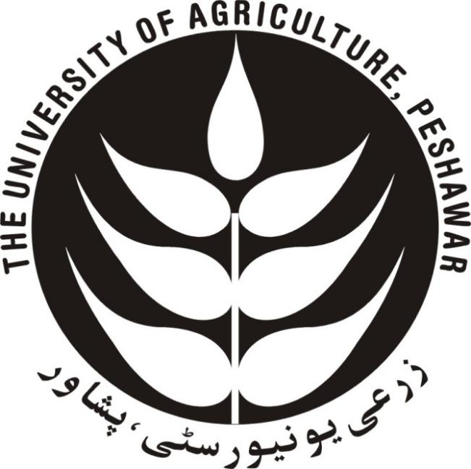

**DEPARTMENT OF AGRONOMY**

**FACULTY OF CROP PRODUCTION SCIENCES**

**THE UINVERSITY OF AGRICULTURE, PESHAWAR**

**KHYBER PAKHTUNKHWA-PAKISTAN**

**SEPTEMBER, 2023**

**SOYBEAN SEED OPTIMIZATION UNDER SEED INTENSIFICATION AND SEEDBED PRACTICES**

**BY**

**SOHAIB KHAN**

*A thesis submitted to The University of Agriculture Peshawar in partial fulfillment of the requirements for the degree of*

**MASTER OF SCIENCE (HONS) IN AGRICULTURE**

**(AGRONOMY)**

**Approved by:**

**_____________________** Chairman Supervisory Committee

Prof. Dr. Habib Akbar

**_____________________** Co-supervisor for research

Dr. Muhammad Asim

SRO (CCRI)

**_____________________** Member (Major Field of Study)

Dr. Shahen Shah

Associate Professor

**_____________________** Member (Minor Field of Study)

Prof. Dr. Dost Muhammad

Dept. of Soil and Environment Sciences

**_____________________** Chairman & Convener Board of Studies

Prof. Dr. Habib Akbar

**_____________________** Dean Faculty of Crop Production Sciences

Prof. Dr. Jehan Bakht

**____________________** Director Advanced Studies and Research

Prof. Dr. Muhammad Sajid

**DEPARTMENT OF AGRONOMY**

**FACULTY OF CROP PRODUCTION SCIENCES**

**THE UINVERSITY OF AGRICULTURE, PESHAWAR**

**KHYBER PAKHTUNKHWA-PAKISTAN**

**SEPTEMBER, 2023**

**SOYBEAN SEED OPTIMIZATION UNDER SEED INTENSIFICATION AND SEEDBED PRACTICES**

Sohaib Khan and Habib Akbar

Department of Agronomy, Faculty of Crop Production Sciences

The University of Agriculture, Peshawar-Pakistan

September, 2023

**Abstract**

Soybeans (*Glycine max* L.) belongs to the Fabaceae family and is highly valued crop due to their protein and oil content. Seed intensification and seedbed preparation are important factors in ensuring successful seed germination and production. A field experiment was carried out in Agronomy Research Farm, The University of Agriculture Peshawar to check better seed rates and seedbed practices for bumper production of soyabean crop. Randomized completely block design with four application was used in the study. The factors investigated were four levels, seed rates (40, 42, 44 and 46 kg ha-1) and seedbed practices (Farm practice, Raised bed edge, Ridge top and Band practice). Analysis of data showed that in case of seed intensification, seed rate of 46 kg ha⁻¹ showed higher emergence (17.4 m⁻²), higher branches plant-1 (4.5 branches) , higher plant population (17 plants m⁻²) and maximum biological yield (4461 kg ha⁻¹). Seed rate of 42 kg ha⁻¹ gave the higher number of pods plant-1 (63.3 pods), higher number of seeds pod-1 (3.6 seeds), higher thousand seed weight (154.3 g), higher seed yield (2116 kg ha⁻¹) and higher harvest index (54%). While in case of seedbed practices, band practices showed higher emergence (14.7 m⁻²), higher number of branches plant-1 (4.1 branches), higher plant population (15 plants m⁻²), higher number of pods plant-1 (65.7 pods), higher number of seeds pod-1 (3.4 seeds), higher thousand seed weight (152.3 g), maximum biological yield (4379 kg ha⁻¹), higher seed yield (2112 kg ha⁻¹) and higher harvest index (50%). The combination of seed rate 46 kg ha⁻¹ with band practices achieved higher biological yield (4461) kg ha⁻¹. In contrast, the combination of a 42 kg ha⁻¹ seed rate with band practices resulted in the maximum thousand seed weight of (156.4 g), higher seed yield (2116 kg ha⁻¹) and maximum harvest index (54%). From the results it is concluded that seed rate of 42 kg ha⁻¹ when sown bands gave good performance and higher production of soyabean and is recommended for cultivation of soyabean.