ARTICLE | DOI: http://dx.doi.org/10.30848/PJB2026-7(19)
BIOCONTROL EFFICACY OF BACILLUS MARISFLAVI XJ-04 AGAINST WATERMELON SCLEROTINIOSE CAUSED BY SCLEROTINIA SCLEROTIORUM
LINGYUE ZHU AND XIAOMEI WANG*
College of Plant Protection, Jilin Agricultural University, Changchun, 130118, China

*Corresponding author's email: xiaomeiw@jlau.edu.cn; Tel: 15590565276
Abstract

Watermelon sclerotiniose has become increasingly severe under conditions of expanded cultivation and continuous cropping. This study aimed to isolate the causal pathogen and evaluate a rhizosphere-derived bacterial antagonist for biological control. Strain LY24, isolated from diseased watermelon stems and vines, was identified as S. sclerotiorum (Lib.) de Bary, through morphological and molecular analyses. Strain LY24 exhibited optimal growth under the following conditions: mannitol as the carbon source, tryptone as the nitrogen source, supplementation of NaCl, pH 9, a temperature of 25°C, and complete darkness. Forty rhizosphere soil samples were collected from watermelon-growing areas in Changchun (including Jiutai District), yielding 300 bacterial isolates. These isolates were screened using a dual-culture (plate confrontation) assay. Strain XJ-04 exhibited strong antagonism against S. sclerotiorum, with a 5.21 mm inhibition zone and a 70.12% inhibition rate. Based on morphological and molecular evidence, combined with Gram staining and standard biochemical tests, strain XJ-04 was identified as B. marisflavi. The fermentation medium was optimized using an orthogonal design combined with response surface methodology. The optimal formulation (sucrose 21.08 g/L, fine bran 9.17 g/L, K₂HPO₄·3H₂O 9.77 g/L, pH 9) increased the inhibition rate to 77.78%, compared to 71.75% before optimization. The optimal fermentation conditions were 100 mL working volume, 30°C, and a 3-day incubation period. The fermentation broth demonstrated stable antifungal activity after treatments involving temperature, pH, storage time, and light conditions. These results indicated that B. marisflavi XJ-04 may be a promising biocontrol candidate for watermelon sclerotiniose.

Key words: Watermelon sclerotia; Biological control; Sclerotinia sclerotiorum; Germination of sclerotia; Bacteriostasis; Fermentation optimization

Introduction

Watermelon (Citrullus lanatus) is an economically important horticultural crop cultivated worldwide, particularly in Asia and the Americas. In China, large-scale production and continuous cropping have intensified soil-borne diseases, which threaten sustainable watermelon cultivation by reducing yield and fruit quality. Among these diseases, watermelon sclerotiniose (white mold/ Sclerotinia stem rot) has emerged as a major constraint on production in major production regions (Bolton et al., 2006).
Watermelon sclerotiniose is caused by S. sclerotiorum (Lib.) de Bary, a destructive necrotrophic fungus with a global distribution. A defining biological characteristic of S. sclerotiorum is its ability to form sclerotia-compact survival structures that persist in soil and serve as major inoculum sources, driving long-term disease recurrence. The pathogen also has a broad host range and can infect many economically important crops. This polyphagous nature complicates disease management and limits the effectiveness of crop rotation. Furthermore, disease outbreaks may occur across multiple growth stages and are typically favored by cool and humid conditions. As a result, achieving effective control is challenging and often varies across locations and seasons (Yang et al., 2018).
Current management of diseases caused by S. sclerotiorum relies mainly on chemical fungicides. Although fungicides can suppress mycelial growth, they often have limited efficacy against sclerotia persisting in the soil. Moreover, the necessity for repeated applications not only increases environmental burden but may also contribute to reduced sensitivity in pathogen populations. In addition to chemical control, agronomic practices aim to reduce soil sclerotia or create crop-favorable conditions that limit pathogen survival and infection. Breeding resistant cultivars offers an economical strategy that can reduce pesticide use and management costs. However, effective resistance against S. sclerotiorum is not always available or may prove insufficiently stable under diverse production conditions. Therefore, biological control has emerged as a promising approach for sustainable disease management. This approach not only reduces chemical inputs but also supports agricultural product safety and quality (Sharma et al., 2015; Willbur et al., 2019).
Among microbial biocontrol candidates, Bacillus species are widely studied because they can produce multiple antifungal metabolites and are generally suitable for industrial fermentation and formulation. However, strong antagonism observed in laboratory assays does not always translate into reliable efficacy under field conditions. Furthermore, field performance can be significantly influenced by environmental stress, as well as by production-related factors such as fermentation conditions and product stability (Liu, 2019). Accordingly, the optimization of fermentation medium and stability assessment are essential for developing practical biocontrol products. However, these critical aspects remain underexplored in many screening-based studies (Derbyshire & Denton‐Giles, 2016).
Based on this context, we hypothesized that rhizosphere soils from watermelon production areas contain bacterial strains with strong antagonistic activity against S. sclerotiorum, and that optimizing fermentation medium and conditions can enhance and stabilize antifungal activity. Therefore, this study aimed to address the following objectives: (1) to isolate and identify the causal pathogen of watermelon sclerotiniose as strain LY24 of S. sclerotiorum and characterize its growth requirements; (2) to isolate and screen rhizosphere bacteria for antagonistic activity, identifying the effective strain as Bacillus marisflavi (B. marisflavi) XJ-04 using morphological, molecular, physiological, and biochemical analyses; and (3) to optimize fermentation medium and conditions while evaluating the stability of the fermentation broth under different temperatures, pH levels, storage time, and light conditions. Overall, this work identified B. marisflavi XJ-04 as a promising antagonistic bacterium against S. sclerotiorum, demonstrating that fermentation optimization improves its inhibitory activity while maintaining stability. These findings provide a scientific basis for developing a microbial biocontrol strategy for sustainable management of watermelon sclerotiniose.

Materials and Methods

Experimental materials

Pathogen and biocontrol strain sources: Symptomatic watermelon stems and vines were collected from a watermelon production base (Jiutai District, Changchun, China) for pathogen isolation. Rhizosphere soil samples were also collected from healthy watermelon plants in production areas around Changchun (including Jiutai District) for antagonistic bacterial isolation. The target pathogen used in antagonism tests was S. sclerotiorum strain LY24, obtained in this study. The antagonistic bacterium selected for further investigation was designated XJ-04.

Media: Potato dextrose agar (PDA) and potato dextrose broth (PDB) were used for fungal culture. Luria-Bertani (LB) medium was used for bacterial culture. Additional differential/ biochemical media for bacterial characterization, including those for methyl red (MR), Voges-Proskauer (VP), and hydrogen sulfide tests, were prepared following standard protocols.

Isolation, pathogenicity test, and identification of the pathogen

Isolation and purification of the pathogen: The pathogenesis was isolated using a tissue isolation method. Small tissue blocks (approximately 0.5 cm × 0.5 cm) were excised from the boundary between diseased and healthy tissue (Fang, 2007). Tissue blocks were surface-disinfected sequentially in 3% sodium hypochlorite (1 min) and 75% ethanol (1 min, twice), rinsed twice with sterile distilled water, blotted dry, and placed on PDA plates (five pieces/plate). Plates were incubated at 25°C in the dark. Hyphal tips were transferred to fresh PDA plates until pure cultures were obtained. The purified isolate was designated LY24 and stored at 4°C.
Pathogenicity test and Koch’s postulates: Strain LY24 was cultured on PDA at 25°C for 7 days. Mycelial plugs (8 mm diameter) from growing colony margins were placed onto wounded stems of healthy watermelon plants; sterile PDA plugs served as controls. Plants were maintained under ambient conditions and l monitored for symptoms for 7 days. The pathogen was re-isolated from symptomatic tissues and confirmed to be morphologically identical to the original isolate, thereby completing Koch’s postulates.

Morphological identification: The colony morphology of LY24 on PDA was recorded, including colony appearance, growth pattern, and sclerotia formation. Hyphal morphology was observed under a light microscope following standard slide-mount procedures.

Molecular identification and phylogenetic analysis: Fungal genomic DNA was extracted from fresh mycelia using a CTAB-based protocol. The internal transcribed spacer (ITS) region and a β-tubulin fragment were amplified using primers ITS1/ITS4 and Bt2a/Bt2b, respectively (Samson et al., 2014). PCR cycling was: 94°C for 5 min; 35 cycles of 94°C for 45 s, 53°C for 30 s, and 72°C for 45 s; followed by 72°C for 5 min (Visagie et al., 2014). PCR products were verified by agarose gel electrophoresis and sequenced commercially. Sequences were analyzed using BLAST against NCBI, and a phylogenetic tree was constructed using the neighbor-joining method in MEGA (version 7.0) (Houbraken et al., 2014).

Determination of biological characteristics of the pathogen: The effects of carbon source, nitrogen source, inorganic salt, pH, temperature, and light on mycelial growth of strain LY24 were evaluated on PDA-based media. For each assay, an 8 mm mycelial plug was placed at the center of each plate. Each treatment contained three replicate plates. Colony diameter was measured using the cross method when the control colony reached approximately 90 mm.

Carbon source: Glucose in PDA was replaced with equal amounts of sucrose, corn flour, lactose, fructose, maltose, mannitol, or dextrin.

Nitrogen source: Selected organic and inorganic sources were individually added to the basal medium to assess their effects on fungal growth.

Inorganic salts: The effects of various inorganic salts on mycelial growth were evaluated by individually supplementing the basal medium with NaCl, KCl, KH₂PO₄, K₂HPO₄·3H₂O, MgSO₄·7H₂O, FeSO₄·7H₂O, and CaCO₃.

pH, temperature, and light: Media pH was adjusted to 2-13 before sterilization. Temperature effects were tested at 4, 15, 20, 25, 30, and 35°C in darkness. Light effects were examined at 25°C under continuous darkness, continuous light, and 12 h light/12 h dark cycles.

Isolation, screening, and identification of antagonistic bacteria

Soil sampling and bacterial isolation: Rhizosphere soil was collected using a five-point sampling method. Samples were air-dried in the shade, sieved (60 mesh), and stored at 4°C until further use (Amein et al., 2008). Soil suspensions were prepared in sterile water and serially diluted (10⁻¹ to 10⁻⁷). The dilutions were plated on bacterial isolation medium and incubated at 28°C for 2-3 days. Single colonies were purified by streaking and preserved. Following this procedure, 300 bacterial isolates were obtained from 40 soil samples (Zhou et al., 2020). Plates were incubated until the control fungus approached the measurement endpoint. The width of the inhibition zone (mm) was then recorded. Each isolate was tested in triplicate.

Secondary screening (fermentation broth assay): Candidate antagonists selected from the primary screening were cultured in 150 mL of LB broth at 28°C and 180 rpm for 48 h. The cultures were then centrifuged (12,000 rpm, 5 min), and the supernatant was filtered (0.45 μm) to obtain sterile cell-free fermentation broth.
To evaluate antifungal activity, fermentation broth was mixed with molten PDA at a 1:5 ratio (broth: PDA) and poured into plates. Each plate was inoculated with an 8 mm fungal plug and incubated at 28°C for 3 days. Control plates contained sterile water mixed with PDA at the same ratio. Colony diameter was measured, and the inhibition rate (%) (Yasmin & Shamsi, 2019) was calculated as:

Inhibition rate (%) = [(Dc − Dt) / Dc] × 100

where Dc is the colony diameter in the control and Dt is the colony diameter in the treatment. Each treatment was performed in triplicate.

Effect on sclerotia germination: Uniform sclerotia of S. sclerotiorum were washed with sterile water, surface-sterilized in 75% ethanol for 3 min, and dried on sterile filter paper. Twenty-five sclerotia were soaked in fermentation broth for 30 min, with the control group soaked in sterile LB for 30 min. After drying, sclerotia were placed onto PDA plates (five per plate) and incubated at 25°C. Germination was recorded at 1, 3, and 5 days. Germination inhibition rate (%) was calculated relative to the control. Three replicate plates were used per treatment.

Identification of antagonistic bacteria: The antagonistic bacterium was characterized based on morphological, physiological, biochemical, and molecular analyses. Colony appearance and cell morphology were recorded. Physiological and biochemical tests, including Gram staining, catalase test, MR test, VP test, and hydrogen sulfide test, were performed according to standard bacteriological procedures (Anon., 1978; Buchanan & Gibbons, 1984; Dong & Cai, 2001). For molecular identification, genomic DNA was extracted from an overnight bacterial culture. The 16S rRNA gene was amplified by PCR using primers 27F/1492R under the following conditions: 94°C for 5 min; 35 cycles of 94°C for 45 s, 53°C for 30 s, and 72°C for 45 s; followed by 72°C for 5 min. PCR products were verified by gel electrophoresis and sequenced. The obtained sequences were compared against the NCBI database using BLAST, and phylogenetic analysis was conducted in MEGA (v11.0) using the neighbor-joining method.
Optimization of fermentation medium and conditions for strain XJ-04

Single-factor screening of medium components: Using inhibition rate against S. sclerotiorum as the response index, strain XJ-04 was fermented in media with different carbon sources, nitrogen sources, inorganic salts, and initial pH values (Casas López et al., 2004; Hajjaj et al., 2001). Cultures were incubated at 28°C and 180 rpm for 2 days. Fermentation broth was prepared as in Section 2.4.3, and the inhibition rate was measured as described above.

Orthogonal design: Four factors (carbon source, nitrogen source, inorganic salt, and pH) were evaluated using an L9 (3⁴) orthogonal design, with each factor tested at three levels. The inhibition rate served as the evaluation index, and the optimal combination was selected using intuitive and range analyses.

Response surface optimization of component concentrations: Based on the optimal component combination identified by the orthogonal test, the concentrations of sucrose, fine bran, and K₂HPO₄·3H₂O were further optimized. Single-factor ranges were evaluated (sucrose 5-25 g/L; fine bran 5-25 g/L; K₂HPO₄·3H₂O 2.5-12.5 g/L) under standard conditions (28°C, 180 rpm, 2 days, and pH 6.0). A Box-Behnken design (three factors, three levels) was then applied. Data fitting and model optimization were conducted using Design-Expert (v8.0.6). The predicted optimum was validated experimentally (Morita et al., 1985; Wang et al., 2012; Dertli et al., 2016; Shu et al., 2016; Chen et al., 2018; Song et al., 2018; Wang et al., 2018).

Optimization of fermentation conditions: Using the optimized medium, working volume (50, 75, 100, 125, 150 mL in a 250 mL flask), fermentation time (1-5 days), and temperature (15-35°C) were evaluated for their effects on antifungal activity. The inhibition rate against S. sclerotiorum was used as the response index.

Stability of fermentation broth: The stability of fermentation broth was evaluated by measuring its inhibition rate after the following treatments:

- Thermal treatment: 20, 40, 60, 80, 100, and 120°C for 30, 60, and 90 min.
- pH stability: pH 2, 4, 6, 8, 10, and 12 for 30, 60, and 90 min, then readjusted to original pH and sterile-filtered (0.22 μm) (Velmourougane & Prasanna, 2024).
- Light stability: exposure to fluorescent light (30 cm) for 1-6 h and UV light (30 W, 30 cm) for 20-120 min.
- Storage stability: storage at room temperature and 4°C for 10, 20, and 30 days.
- Passage stability: generations 1-5 (subcultured every 5 days); fermentation broth from each generation was assessed.

For all treatments, broth was mixed with PDA at a 1:5 ratio, and the inhibition rate against S. sclerotiorum was calculated as in Section 2.4.3.
Growth promotion and detached leaf assays

Seed germination and seedling growth: A total of 350 uniform watermelon seeds were surface-disinfected and divided into seven groups. Seeds were soaked for 10 h in fermentation broth dilutions (broth:water = 1:5, 1:10, 1:20, 1:50, 1:75, and 1:100) or sterile water (control). After that, seeds were incubated at 25°C in darkness, and germination was recorded daily from day 1 to day 7. Germination rate and potential were calculated using standard formulas. Germinated seeds were transplanted to seedling pots. After 30 days, plant height, root length, stem diameter, fresh weight, and dry weight were measured.

Detached leaf assay: Watermelon seeds were surface-disinfected and germinated. Seedlings were grown until leaves were fully expanded and uniform in size. Leaves were excised, washed, and surface-sterilized using ethanol, followed by sterile water rinses. After that, the leaves were dried under sterile conditions. Fermentation broth was diluted with sterile water (broth: water = 1:1, 1:5, 1:10, 1:15, 1:20). Leaves were then placed in sterile trays lined with moist cotton. A volume of 100 μL of each dilution was applied to the leaf surface; sterile water served as the control. After drying, leaves were inoculated with S. sclerotiorum and incubated at 25°C. Lesion diameter was measured after 7 days, and the inhibition rate was calculated relative to the control. Three replicates were used per treatment (Rotich & Mmbaga, 2023; Velmourougane & Prasanna, 2024).

Statistical analysis

Differences among treatments were assessed using one-way analysis of variance (ANOVA), and means were separated using Duncan’s multiple range test when ANOVA indicated significant differences. Range analysis was used to evaluate the effects of carbon source, nitrogen source, inorganic salt, and pH on antifungal activity in the orthogonal test. Response surface methodology was then applied to optimize the concentrations of key fermentation medium components. Regression model fitting, ANOVA, and lack-of-fit testing were performed using Design-Expert software to assess model significance and reliability. All data were presented as mean ± standard deviation (SD) and analyzed using SPSS software. Differences were considered statistically significant at p<0.05.

Results

Isolation, pathogenicity, and identification of the watermelon sclerotiniose pathogen: A fungal strain, designated LY24, was isolated from symptomatic stem tissues of watermelon plants showing typical symptoms of sclerotiniose (Fig. 1). Pathogenicity assays confirmed that watermelon plants inoculated with strain LY24 developed typical disease symptoms within 7 days, while control plants inoculated with sterile agar plugs remained healthy (Fig. 2). The pathogen was successfully re-isolated from diseased tissues, and the colony morphology of the re-isolated strain was identical to that of LY24. These results fulfilled Koch’s postulates, confirming LY24 as the causal agent of watermelon sclerotiniose (Fig. 3).
On PDA, strain LY24 produced white, cottony mycelia that expanded radially and uniformly (Fig. 3). With prolonged incubation, compact sclerotia formed within the mycelial mass. These sclerotia initially appeared white, then gradually turned brown, and finally became black after approximately 15 days. Most sclerotia were spherical, with some irregular forms. Microscopic examination revealed septate hyphae (4.2 to 7.0 μm diameter), with irregular septal spacing and slight constrictions at branching points, consistent with S. sclerotiorum (Fig. 4).
Molecular identification further supported the morphological observations. PCR amplification of the ITS region yielded a fragment of approximately 504 bp (Fig. 5). Sequence analysis showed that the ITS sequence of strain LY24 shared 99% similarity to reference sequences of S. sclerotiorum. Phylogenetic analysis based on ITS sequences further clustered strain LY24 within the S. sclerotiorum clade, confirming its taxonomic identity (Fig. 6).

Biological characteristics of S. sclerotiorum strain LY24: The mycelial growth of S. sclerotiorum strain LY24 was significantly influenced by nutritional components and environmental conditions. Among the tested carbon sources, mannitol supported the greatest mycelial growth, followed by fructose and lactose. In contrast, maltose resulted in the weakest growth. For nitrogen sources, tryptone was the most favorable source for mycelial growth, while urea did not support mycelial growth beyond the initial inoculum size, indicating strong inhibition (Fig. 7).
Inorganic salts also notably affected the mycelial development of strain LY24. NaCl supplementation resulted in the largest colony diameters, followed by KCl and KH₂PO₄. In contrast, FeSO₄·7H₂O resulted in the weakest mycelial growth (Fig. 7).
Environmental factors strongly influenced mycelial growth. Optimal growth was observed at pH 9, while no mycelial growth occurred at pH values of 11 or higher. Temperature also had a marked effect on growth. The optimal temperature for mycelial growth was 25°C. No growth was observed at 4°C, 30°C, or 35°C. Light conditions also affected growth, with continuous darkness being optimal and continuous light resulting in the weakest growth (Fig. 8).

Screening and identification of antagonistic bacteria: A total of 300 bacterial strains were isolated from rhizosphere soil samples of healthy watermelon plants. Preliminary screening using dual-culture assays against S. sclerotiorum identified five strains that produced clear inhibition zones, indicating antagonistic activity. Among these strains, XJ-04 and LY-15 showed larger inhibition zones than the other candidates (Table 1).
Secondary screening, based on fermentation broth assays, further differentiated the antagonistic performance of these strains. The fermentation broths of strains SY-27, XG-69, and JH-105 exhibited relatively weak inhibitory effects on the mycelial growth of S. sclerotiorum. In contrast, strains XJ-04 and LY-15 showed strong antifungal activity, with inhibition rates exceeding 70%. Among them, strain XJ-04 demonstrated the strongest antagonistic effect, with an inhibition zone width of approximately 5.21 mm and an inhibition rate of 70.12%. Additionally, it also showed enhanced inhibition of sclerotia germination, with an inhibition rate of 60% (Table 2). Therefore, strain XJ-04 was selected for further study (Fig. 9).

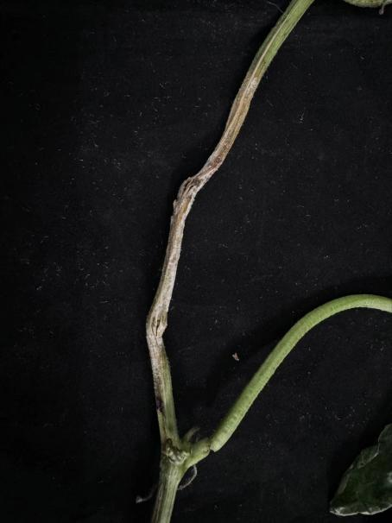
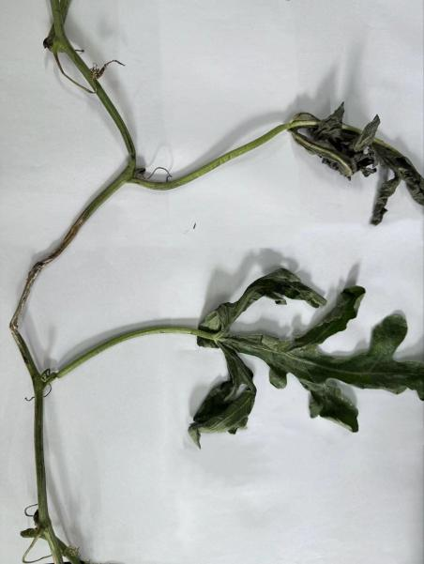

Fig. 1. Stem symptoms of watermelon sclerotiniose.

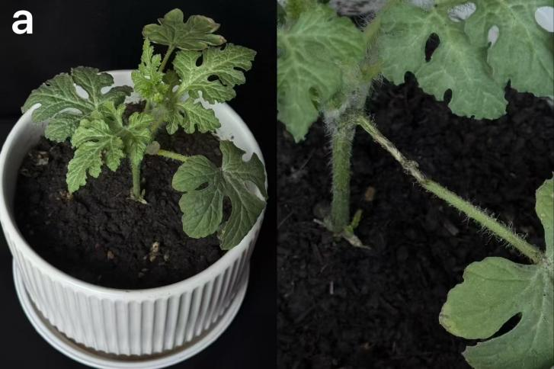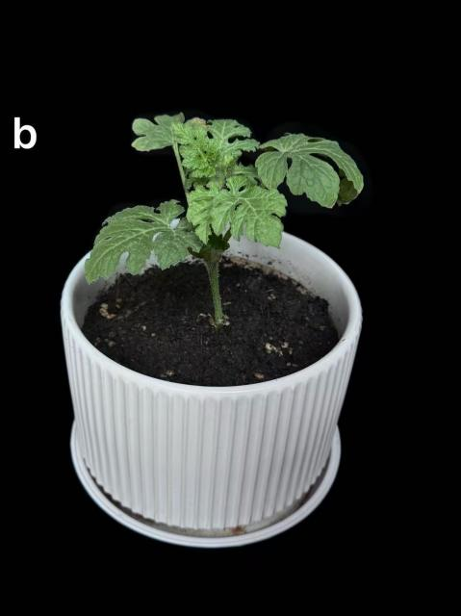

Fig. 2. Pathogenicity test results of S. sclerotiorum strain LY24 on watermelon plants.

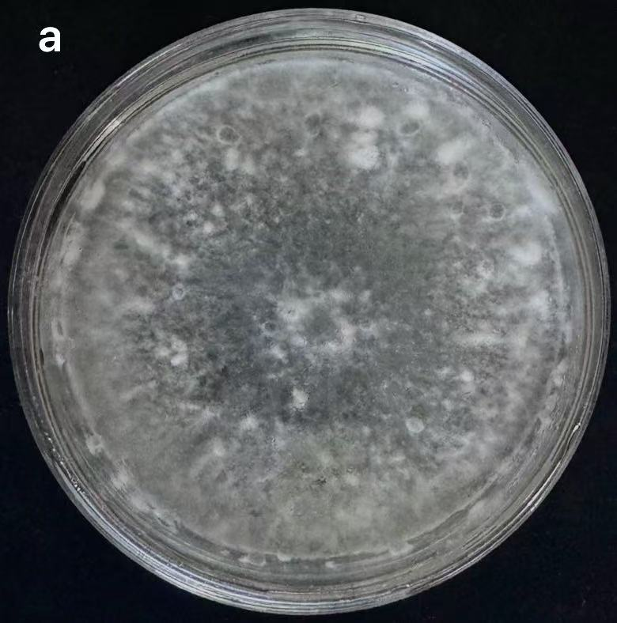
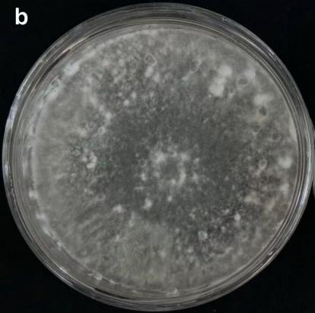

Fig. 3. Comparison of colony morphology between S. sclerotiorum strains LY24 and LY25.

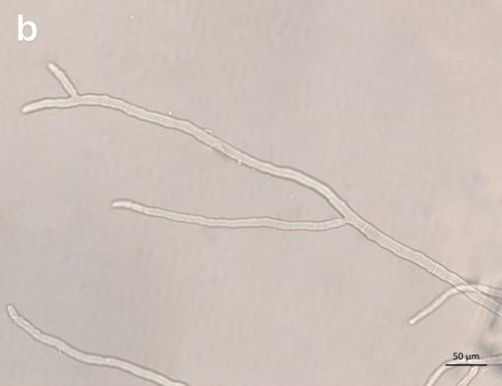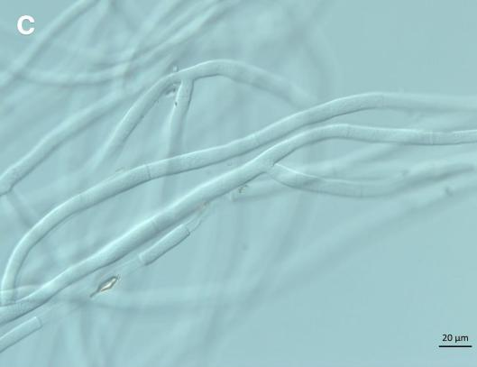

Fig. 4. Macrostructure and microstructure of S. sclerotiorum strain LY24.

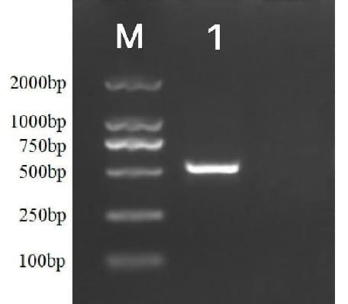

Fig. 5. Electrophoretic band of PCR product of the ITS region from S. sclerotiorum strain LY24.
Table 1. Inhibitory effect of 5 soil bacteria on S. sclerotiorum.
No. Code | Inhibitory zone(Mm)  Inhibition zone | Rescreening inhibition rate (%) Inhibition rate of secondary screening
XJ-04 | 5.21 ± 0.2450^{c} | 70.12 ± 0.6710^{d}
LY-15 | 4.93 ± 0.1652^{c} | 69.32 ± 3.2216^{d}
SY-27 | 3.76 ± 0.4328ª | 50.32 ± 0.6727ª
XG-69 | 4.55 ± 0.2658^{b} | 59.63 ± 3.9452^{b}
JH-105 | 4.68 ± 0.1747^{ab} | 64.60 ± 0.8278^{c}
Note: Using SPSS for data analysis, different lowercase letters indicate significant differences at p<0.05

Table 2. Effect of fermentation broth of strain XJ-04 on sclerotia germination.
Treatment | Number of sclerotia germination in 3d | Inhibition rate (%)
Fermentation supernatant | 10 | 60
Control (CK) | 25 | /

Inhibitory rates = | Colony diameter of control group – Treatment group colony diameter | x 100 | (1)
Inhibitory rates = | Colony diameter of control group – The diameter of the fungus cake | x 100 | (1)

Inhibitory rates = | Control sclerotium germination number – The number of treated sclerotia germination | x 100 | (2)
Inhibitory rates = | Control sclerotium germination number | x 100 | (2)

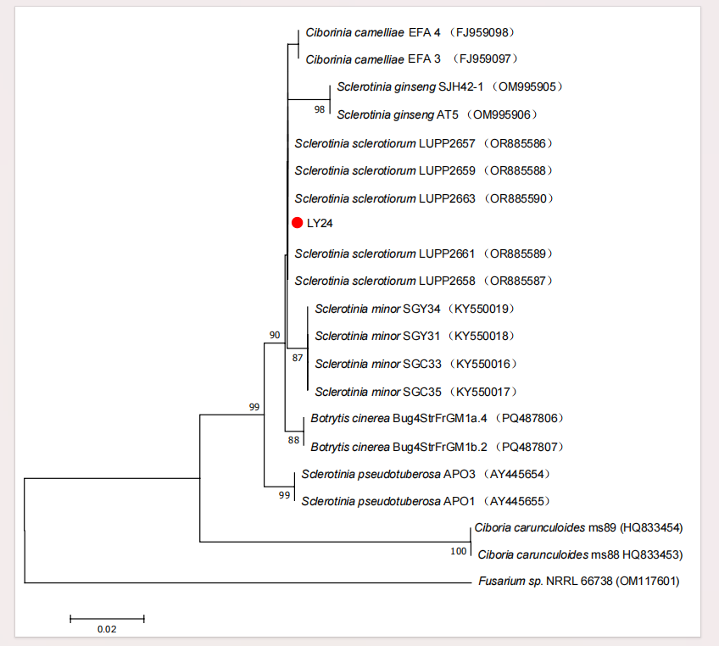

Fig. 6. The phylogenetic tree of S. sclerotiorum strain LY24 constructed by Mega 7.0.based on ITS gene.

Fig. 7. Mycelial growth of S. sclerotiorum strain LY24 with different carbon sources, nitrogen sources, and inorganic salts. Note: Using SPSS for data analysis, different lowercase letters indicate significant differences at p<0.05.

Fig. 8. Mycelial growth of S. sclerotiorum strain LY24 under different pH, temperature, and light conditions. Note: Using SPSS for data analysis, different lowercase letters indicate significant differences at p<0.05.

Table 3. Some physiological and biochemical characteristics of strain XJ-04.
Item | Result
Gram reaction | +
Contact enzyme reaction | +
MR reaction | +
VP Reaction | -
Hydrogen sulfide reaction | -
Note: "+" Positive,"-" Negative

According to morphological observation, strain XJ-04 formed light-yellow, smooth, convex colonies. Cells were Gram-positive, rod-shaped, and spore-forming. Physiological and biochemical characterization further indicated that the strain was positive for catalase activity and the MR test, but negative for VP and hydrogen sulfide reactions. These characteristics were consistent with those of the genus Bacillus (Fig. 10).
Molecular identification based on 16S rRNA gene sequencing showed that strain XJ-04 shared 97.87% sequence similarity with B. marisflavi (Table 3; Figs. 11, 12). Phylogenetic analysis further clustered strain XJ-04 together with reference strains of B. marisflavi, supporting its identification as B. marisflavi (Fig. 13).

Optimization of fermentation conditions and stability of B. marisflavi XJ-04: The antifungal activity of B. marisflavi XJ-04 fermentation broth against S. sclerotiorum was significantly influenced by the composition of the fermentation medium. Single-factor screening showed that carbon source, nitrogen source (Fig. 14), inorganic salt, and pH (Fig. 15) affected the inhibition rate. Orthogonal analysis identified the optimal combination of medium components as sucrose, fine bran, and K₂HPO₄·3H₂O at pH 9, resulting in an inhibition rate of 71.75% (Tables 4-6).
Response surface methodology was used to further optimize the concentrations of these components (Fig. 16; Tables 7 and 8). The optimal formulation predicted by the model was 21.08 g/L sucrose, 9.17 g/L fine bran, and 9.77 g/L K₂HPO₄·3H₂O, with a predicted inhibition rate of 77.99% (Table 9; Fig. 17). Validation experiments yielded an inhibition rate of 77.78%, which was consistent with the predicted value (Fig. 18). The optimized fermentation broth also showed enhanced inhibition of sclerotia germination, with an inhibition rate of 64%, which was higher than that observed prior to optimization (Table 10).

Table 4. Factors and levels of orthogonal design.
Horizontal  level | Factor
Horizontal  level | A Carbon source | B Nitrogen source | C Inorganic salt | D pH
1 | Maltose | Urea | K₂HPO₄·3H₂O | 7
2 | Mannitol | Fine bran | FeSO₄·7H₂O | 8
3 | Sucrose | Diammonium phosphate | CaCO₃ | 9
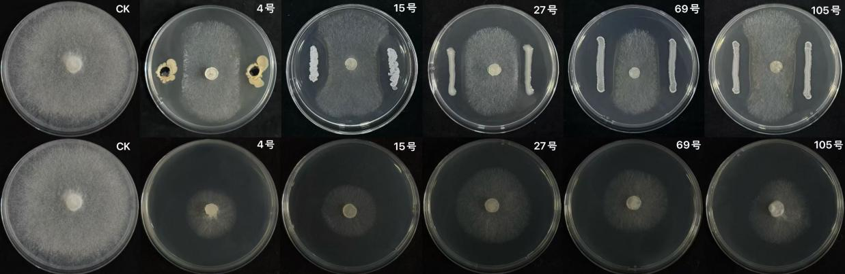

Fig. 9. The antibacterial effect of 5 strains of soil bacteria in primary screening.

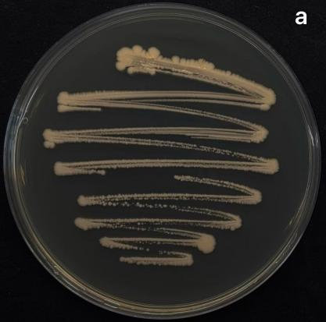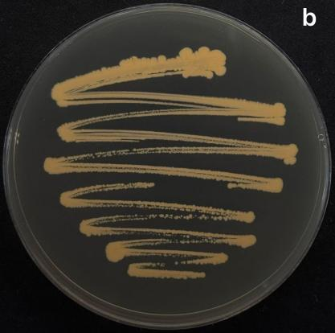

Fig. 10. Colony morphology of strain XJ-04. (a) Colony front; (b) The back of the colony.

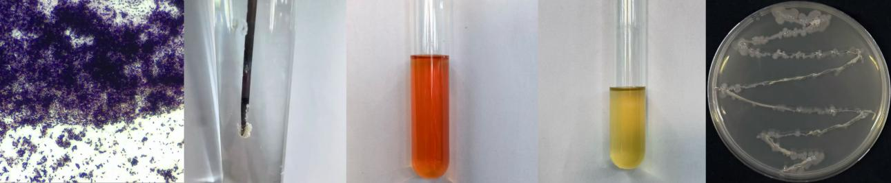

Fig. 11. Physiological and biochemical characteristics of strain XJ-04.

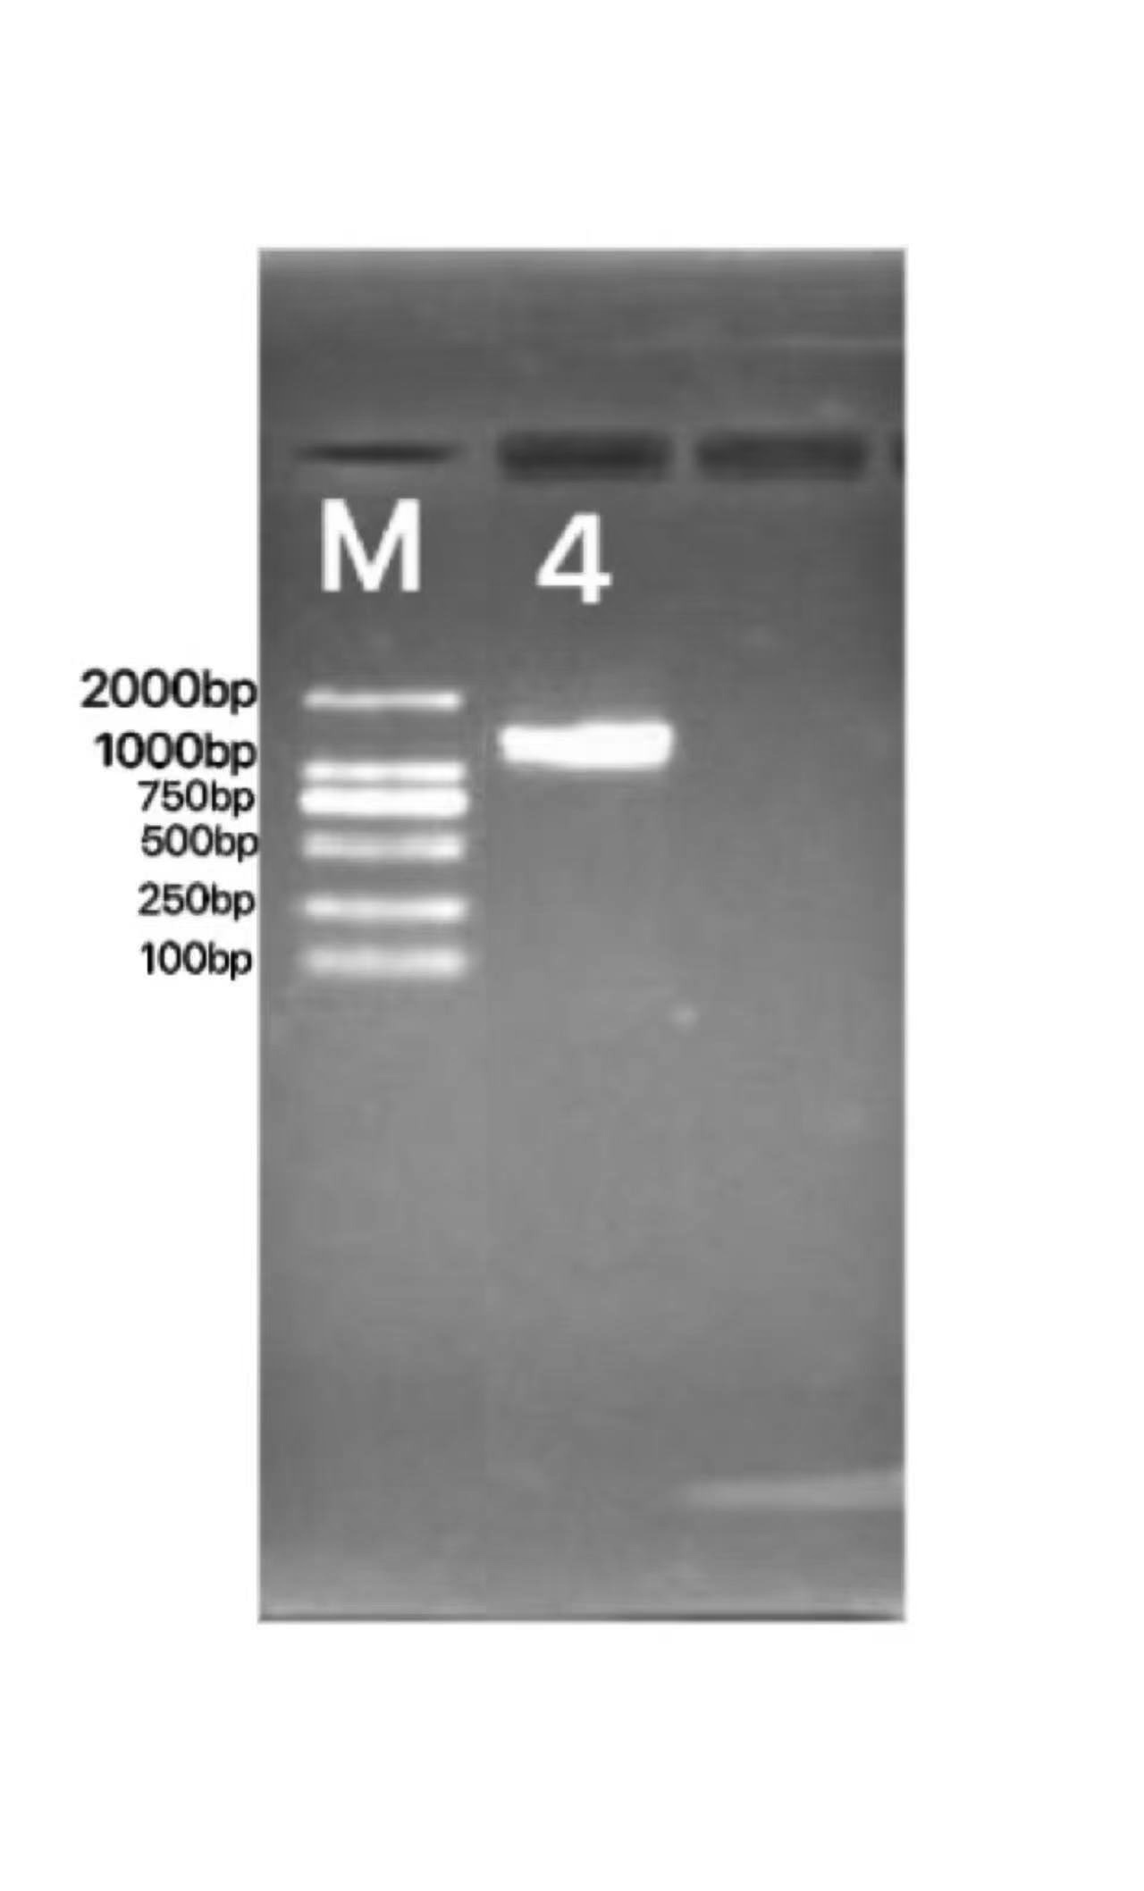

Fig. 12. Electrophoretic band of the PCR product of strain XJ-04. M: DL2000Maker; 4: 16S rDNA.
Fermentation conditions further affected antifungal activity. The highest inhibition rate was achieved at a fermentation temperature of 30°C, a fermentation time of 3 days, and a working volume of 100 mL. Under these conditions, the fermentation broth exhibited maximal antifungal activity against S. sclerotiorum (Fig. 19).
Stability assays demonstrated that the antifungal activity of the fermentation broth was relatively stable under a range of environmental conditions. The fermentation broth exhibited stable antifungal activity across a range of conditions, including temperatures up to 80°C (Fig. 20a), pH 2-10 (Fig. 20b), light irradiation (Fig. 20c, Fig. 20d), and storage under both room temperature and 4°C (Fig. 20e). In addition, successive subculturing of strain XJ-04 did not markedly reduce the antifungal activity of the fermentation broth, indicating good passage stability (Fig. 20f).

Table 5. Results of the orthogonal test.
Test number | Test factor Factor |  |  |  | Inhibition rate (%)
Test number | A Carbon source | B Nitrogen source | C Inorganic salt | D pH | Inhibition rate (%)
1 (A₁B₁C₁D₁) | Maltose | Urea | K₂HPO₄·3H₂O | 7 | 98.77 ± 2.1362^{d}
2 (A₁B₂C₃D₂) | Maltose | Fine bran | CaCO₃ | 8 | 64.42 ± 2.4606ª
3 (A₁B₃C₂D₃) | Maltose | Diammonium hydrogen phosphate | FeSO₄·7H₂O | 9 | 100.00 ± 0.0000^{d}
4 (A₂B₁C₃D₃) | Mannitol | Urea | CaCO₃ | 9 | 99.79 ± 0.1050^{d}
5 (A₂B₂C₂D₁) | Mannitol | Fine bran | FeSO₄·7H₂O | 7 | 47.31 ± 6.3369ª
6 (A₂B₃C₁D₂) | Mannitol | Diammonium hydrogen phosphate | K₂HPO₄·3H₂O | 8 | 65.59 ± 1.4816^{b}
7 (A₃B₁C₂D₂) | Sucrose | Urea | FeSO₄·7H₂O | 8 | 67.73 ± 2.9556^{b}
8 (A₃B₂C₁D₃) | Sucrose | Fine bran | K₂HPO₄·3H₂O | 9 | 71.75 ± 4.5160^{c}
9 (A₃B₃C₃D₁) | Sucrose | Diammonium hydrogen phosphate | CaCO₃ | 7 | 100.00 ± 0.0000^{d}
Note: Using SPSS for data analysis, different lowercase letters indicate significant differences at p<0.05

Table 6. Range analysis results of various factors.
Indicators  Index | Test factor Factor
Indicators  Index | A Carbon source | B Nitrogen source | C Inorganic salt | D pH
K1 | 244.19 | 262.29 | 232.11 | 246.08
K2 | 208.69 | 164.48 | 211.04 | 197.74
K3 | 235.48 | 261.59 | 245.21 | 271.54
k1 | 81.40 | 87.43 | 77.37 | 82.03
k2 | 69.56 | 54.83 | 70.35 | 65.91
k3 | 78.49 | 87.20 | 81.74 | 90.51
R | 2.91 | 0.23 | 4.37 | 24.6

Table 7. Variables and level of the Box-Behnken design.
Horizontal  level | Factor
Horizontal  level | X₁ Sucrose addition (g/L) | X₂ The amount of fine bran added (g/L) | X₃ The addition of K₂HPO₄·3H₂O (g/L)
-1 | 15 | 5 | 7. 5
0 | 20 | 10 | 10
1 | 25 | 15 | 12.5

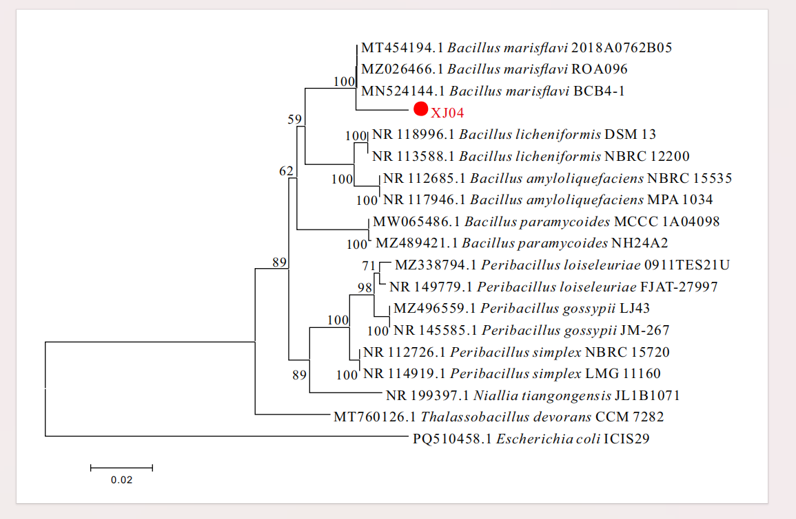

Fig. 13. The phylogenetic tree of strain XJ-04 constructed by Mega 11.0 based on the 16S rDNA sequence.

Fig. 14. Inhibition rate of fermentation with different carbon and nitrogen sources. Note: Using SPSS for data analysis, different lowercase letters indicate significant differences at p<0.05.

Fig. 15. Inhibition rate of fermentation with different inorganic salt and pH. Note: Using SPSS for data analysis, different lowercase letters indicate significant differences at p<0.05.

Fig. 16. The effects of the addition of sucrose, fine bran, and K₂HPO₄·3H₂O on the bacteriostatic rate of fermentation broth. Note: Using SPSS for data analysis, different lowercase letters indicate significant differences at p<0.05.

Fig. 19. The effects of different fermentation time, liquid volume, and temperature treatments on the inhibition rate of fermentation broth. Note: Using SPSS for data analysis, different lowercase letters indicate significant differences at p<0.05.
Table 8. The results of the response surface optimization test for strain XJ-04 fermentation.
Code | Factors and levels |  |  | Y Inhibition rate (%)
Code | X₁ (g/L) | X₂ (g/L) | X₃ (g/L) | Y Inhibition rate (%)
1 | 15.00 | 5.00 | 10.00 | 74.87
2 | 25.00 | 5.00 | 10.00 | 76.16
3 | 15.00 | 15.00 | 10.00 | 73.96
4 | 25.00 | 15.00 | 10.00 | 74.57
5 | 15.00 | 10.00 | 7.50 | 75.60
6 | 25.00 | 10.00 | 7.50 | 76.64
7 | 15.00 | 10.00 | 12.50 | 75.69
8 | 25.00 | 10.00 | 12.50 | 76.42
9 | 20.00 | 5.00 | 7.50 | 76.48
10 | 20.00 | 15.00 | 7.50 | 74.05
11 | 20.00 | 5.00 | 12.50 | 75.02
12 | 20.00 | 15.00 | 12.50 | 75.85
13 | 20.00 | 10.00 | 10.00 | 77.85
14 | 20.00 | 10.00 | 10.00 | 77.92
15 | 20.00 | 10.00 | 10.00 | 78.12
16 | 20.00 | 10.00 | 10.00 | 77.87
17 | 20.00 | 10.00 | 10.00 | 77.75

Table 9. Variance analysis of response surface experimental results.
Source | Sum of squares | Degrees of freedom | Mean square | F-value | P-value Prob > F | Significance
Model | 30.86 | 9 | 3.43 | 116.70 | ＜0.0001 | **
X₁ | 1.68 | 1 | 1.68 | 57.31 | 0.0001
X₂ | 2.10 | 1 | 2.10 | 71.52 | ＜0.0001
X₃ | 0.0055 | 1 | 0.0055 | 0.19 | 0.6779
X₁X₂ | 0.12 | 1 | 0.12 | 3.93 | 0.0877
X₁X₃ | 0.024 | 1 | 0.024 | 0.82 | 0.3959
X₂X₃ | 2.66 | 1 | 2.66 | 90.43 | ＜0.0001
X₁² | 5.45 | 1 | 5.45 | 185.36 | ＜0.0001 | **
X₂² | 14.80 | 1 | 14.80 | 503.71 | ＜0.0001 | **
X₃² | 1.93 | 1 | 1.93 | 65.73 | ＜0.0001
Residual | 0.21 | 7 | 0.029
Lack of Fit | 0.13 | 3 | 0.044 | 2.34 | 0.2149
Pure Error | 0.075 | 4 | 0.019
Cor Total | 31.06 | 16
Note: Using Design Expert software for data analysis, * Indicated significant impact on the results (0.01< p<0.05); ** Indicated that the impact on the results was extremely significant (p<0.01)

Table 10. The effect of optimized fermentation broth of strain XJ-04 on sclerotia germination.
Treatment | Number of sclerotia germination in 3d | Inhibition rate (%)
Fermentation supernatant | 9 | 64
CK | 25 | /

Germinating energy = | The number of seeds germinated at the peak of germination | x 100% | (3)
Germinating energy = | Total number of kernels | x 100% | (3)

Percentage of germination = | Number of germinated seeds | x 100% | (4)
Percentage of germination = | Total number of kernels | x 100% | (4)

Table 11. Effects of fermentation broth of strain XJ-04 on seed germination of watermelon.
Code | Fermentation broth: Water | Germination potential (%) | Germination rate (%)
A | 1:5 | 60 | 87
B | 1:10 | 72 | 90
C | 1:25 | 67 | 82
D | 1:50 | 89 | 96
E | 1:75 | 87 | 90
F | 1:100 | 70 | 92
G | CK | 65 | 85
Effects of B. marisflavi XJ-04 fermentation broth on watermelon growth and disease suppression: The effects of different dilutions of B. marisflavi XJ-04 fermentation broth on watermelon seed germination and seedling growth were evaluated. Low concentrations of the fermentation broth promoted seed germination, whereas higher concentrations exhibited inhibitory effects. Among all treatments, the dilution ratio of 1:50 (fermentation broth: water) resulted in the highest germination potential and germination rate compared to the control (Table 11).

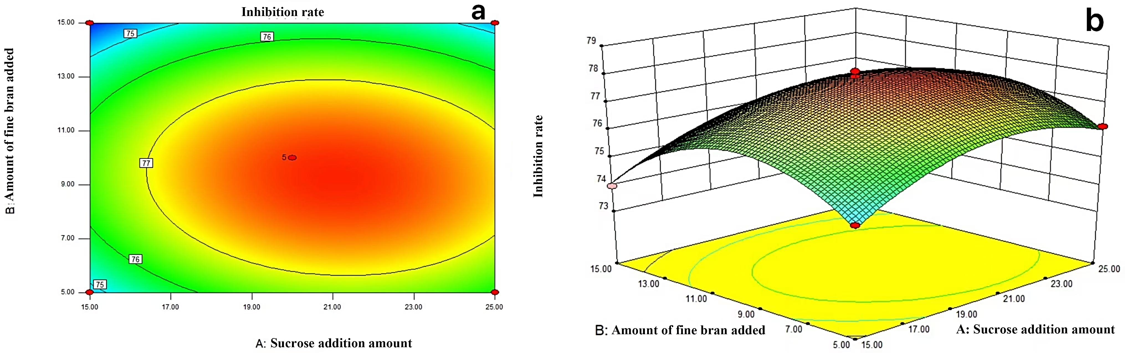

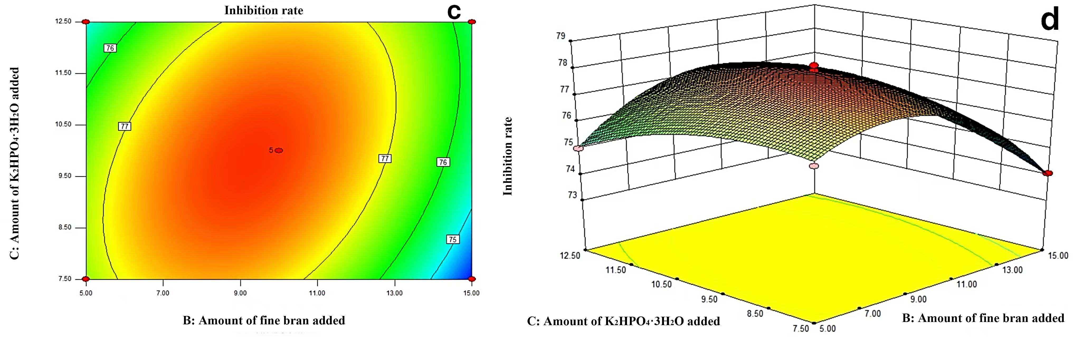

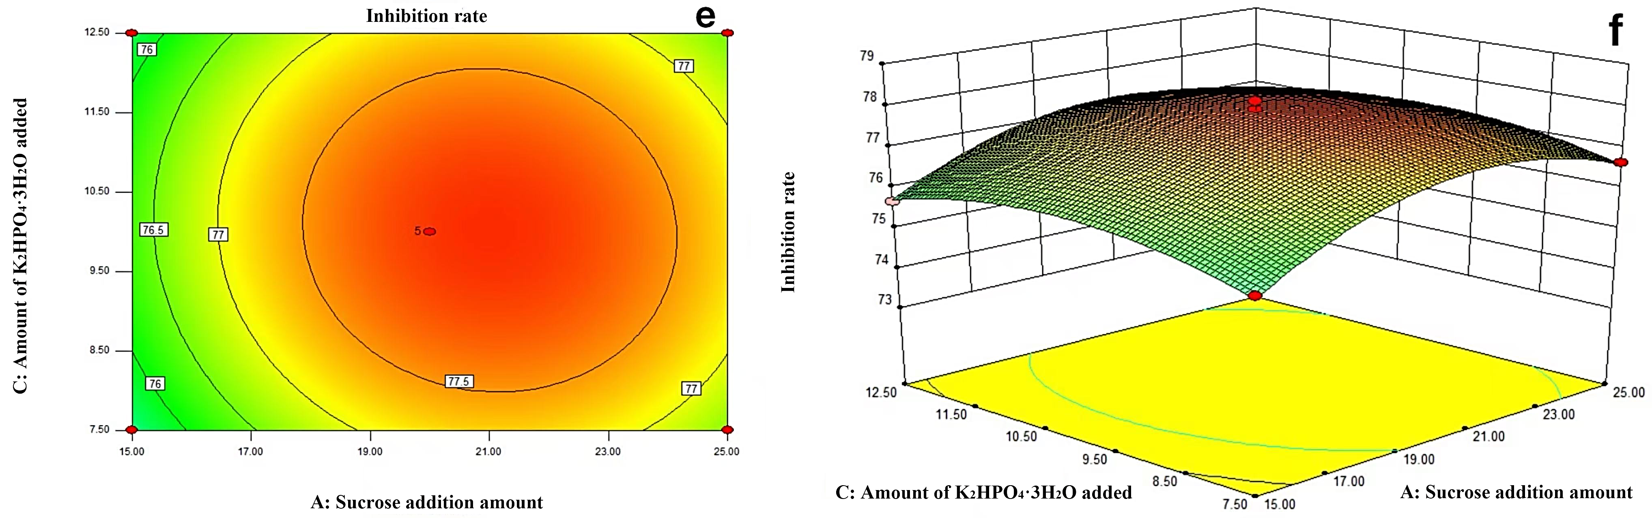

Fig. 17. Contour and 3D surface maps of interactions between factors.

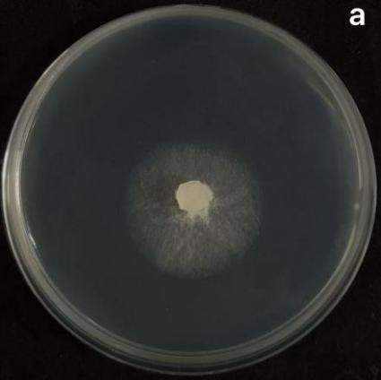
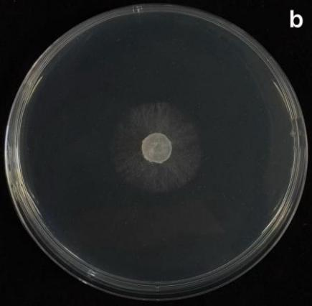

Fig. 18. Comparison of the inhibition rate between initial (a) and optimized (b) fermentation.

Fig. 20. Effects of temperature, pH, light, and storage time on the antifungal activity of fermentation broth from different generations of B. marisflavi XJ-04. (a) Temperature; (b) pH; (c) Incandescent lamp; (d) Ultraviolet lamp; (e) Temperature (f) Storage time.

Table 12. Effects of fermentation broth of strain XJ-04 on the growth of watermelon seedlings.
Fermentation broth : Water | Plant height  (mm) | Root length  (mm) | Stem diameter  (mm) | Fresh weight  (g) | Dry weight  (g)
1:100 (A) | 135.50 ± 3.88^{c} | 46.72 ± 3.34^{ab} | 3.47 ± 0.19ª | 1.28 ± 0.10^{ab} | 0.11 ± 0.02^{b}
1:75 (B) | 130.19 ± 6.03^{bc} | 49.25 ± 1.19^{bc} | 3.47 ± 0.25ª | 1.71 ± 0.10^{d} | 0.16 ± 0.03^{c}
1:50 (C) | 137.67 ± 2.91^{c} | 53.37 ± 1.43^{c} | 3.46 ± 0.08ª | 1.72 ± 0.09^{d} | 0.13 ± 0.03^{bc}
1:25 (D) | 136.96 ± 8.56c | 50.09 ± 1.51^{bc} | 3.57 ± 0.09ª | 1.45 ± 0.07^{bc} | 0.08 ± 0.02^{ab}
1:10 (E) | 121.33 ± 2.17^{ab} | 47.88 ± 2.49^{ab} | 3.49 ± 0.29ª | 1.55 ± 0.15^{cd} | 0.10 ± 0.02^{ab}
1:5 (F) | 114.80 ± 13.03ª | 45.91 ± 3.83^{ab} | 3.42 ± 0.23ª | 1.17 ± 0.12ª | 0.09 ± 0.04^{ab}
CK (G) | 116.44 ± 8.00ª | 43.77 ± 2.57ª | 3.39 ± 0.23ª | 1.12 ± 0.19ª | 0.06 ± 0.02ª
Note: Using SPSS for data analysis, different lowercase letters indicate significant differences at p<0.05
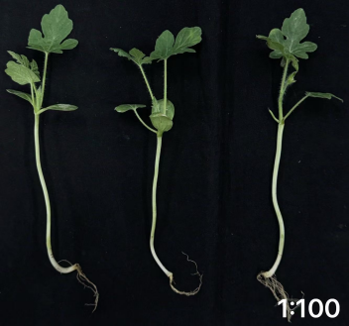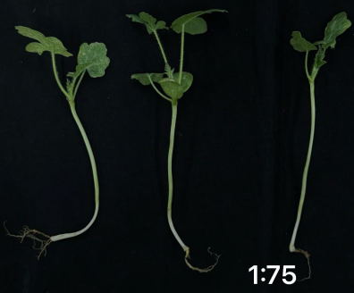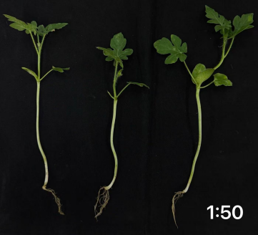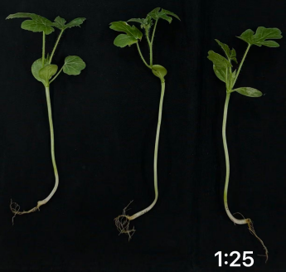

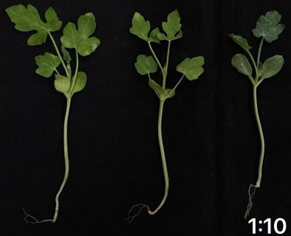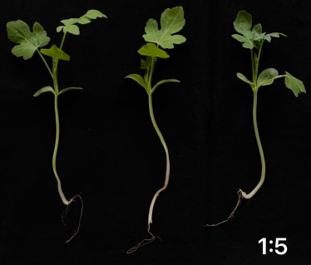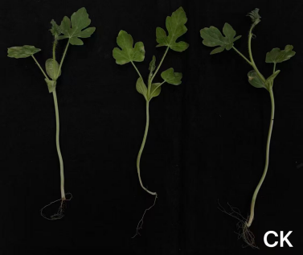

Fig. 21. Effects of fermentation broth of strain XJ-04 on the growth of watermelon seedlings. Fermentation broth: Water = 1:100; 1:75; 1:50; 1:25; 1:10; 1:5; CK.

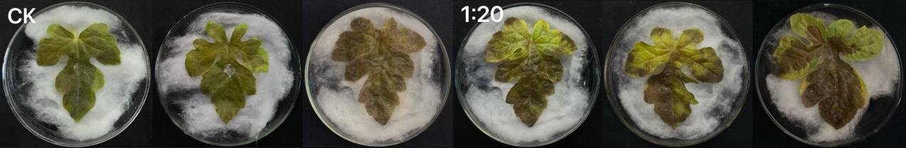

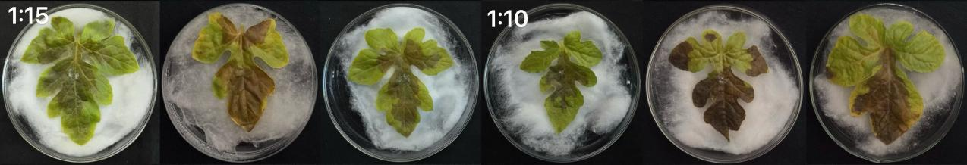

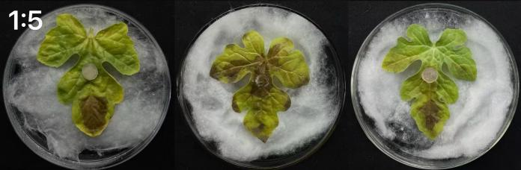

Fig. 22. Antifungal effect of fermentation broth of strain XJ-04 on detached leaves of watermelon S. sclerotiorum.

Table 13. The lesion diameter of watermelon sclerotiniose after the leaves were treated with the fermentation broth of strain XJ-04.
Code | Fermentation  broth: Water | Lesion diameter  (mm)
A | 0:1 | 54.26 ± 1.5245e
B | 1:20 | 49.61 ± 0.5823^{d}
C | 1:15 | 44.66 ± 0.8426^{c}
D | 1:10 | 33.84 ± 1.6038^{b}
E | 1:5 | 20.07 ± 1.0758ª
Note: Using SPSS for data analysis, Different lowercase letters indicate significant differences at p<0.05
Seedling growth parameters were also influenced by the fermentation broth. At appropriate dilutions, the fermentation broth significantly increased plant height, root length, stem diameter, fresh weight, and dry weight relative to the control (Table 12). The most pronounced growth-promoting effects were observed at dilution ratios of 1:50 and 1:75. In contrast, higher concentrations (1:5 and 1:10) reduced growth compared to the control (Fig. 21).
In detached leaf assays, watermelon leaves pretreated with the fermentation broth of strain XJ-04 developed significantly smaller lesions after inoculation with S. sclerotiorum compared to untreated controls (Table 13). Disease suppression increased with increasing fermentation broth concentration. The strongest inhibitory effect on lesion development was observed at dilution ratios of 1:5 and 1:10, while lower concentrations also provided moderate but significant disease reduction (Fig. 22).

Discussion

The present study successfully isolated and identified S. sclerotiorum strain LY24 as the causal agent of watermelon sclerotiniose. Additionally, it demonstrated that B. marisflavi XJ-04, effectively suppressed this pathogen through optimized fermentation conditions. These findings support the potential of Bacillus species as viable biocontrol agents against Sclerotinia diseases in cucurbit crops.
The morphological and molecular characterization of strain LY24 confirmed its identity as S. sclerotiorum. The observed features-including white cottony mycelia, black sclerotia formation, and septate hyphae with characteristic dimensions-are consistent with previous descriptions. Strain LY24 exhibited optimal growth at 25°C and pH 9, with mannitol as the preferred carbon source, aligning with the physiological traits of S. sclerotiorum isolates from various geographical regions (Gómez-Morales et al., 2021). The inability of the pathogen to grow at temperatures above 30°C and its preference for darkness suggest potential for cultural control, but field application remains challenging.
The isolation of B. marisflavi XJ-04 from watermelon rhizosphere soil and its potent antagonistic activity (inhibition rate of 70.12% before optimization) represent a notable discovery. Bacillus species (such as B. velezensis, B. subtilis, and B. amyloliquefaciens) have been extensively studied as biocontrol agents against Sclerotinia (Baptista et al., 2022; Al-Mutar et al., 2023; Hathurusinghe et al., 2025). However, reports specifically documenting B. marisflavi as an antagonist of S. sclerotiorum in watermelon systems remain limited. Recent studies have identified B. marisflavi as a potent producer of diverse secondary metabolites, yet its application in soil-borne disease management remains an emerging field (Gowtham et al., 2021). In this study, the post-optimization antagonistic activity of XJ-04 (77.78%) highlights the untapped potential of this species as a novel microbial resource for sustainable watermelon production. The dual-culture assay and fermentation broth screening approach employed in this study followed standard protocols for identifying promising biocontrol candidates (Ayaz et al., 2024; Miljaković et al., 2020).
Beyond mycelial inhibition, managing watermelon sclerotiniose requires addressing the persistent soilborne sclerotia, which drive disease recurrence (Bolton et al., 2006). In this context, optimized XJ-04 suppressed sclerotia germination by 64%. This source targeted antagonism is essential for field applicability. Unlike chemical fungicides that fail to penetrate sclerotia, XJ-04's robust metabolites and potential cell wall-degrading enzymes can effectively neutralize these survival structures. This dual-action of XJ-04-suppressing both active vegetative growth and dormant inoculum- positions it as a superior candidate for sustained disease control in complex soil environments.
The optimization of fermentation conditions using response surface methodology proved highly effective, increasing the inhibition rate from 70.12% to 77.78%. This 7.66% improvement is comparable to, or even exceeds, the enhancements reported in recent studies on Bacillus fermentation optimization. For instance, optimized fermentation of B. velezensis LZN01 yields a 71.1% inhibition rate against target fungi (Hu et al., 2024), while optimized fermentation of B. siamensis achieves a 4.6-fold increase in fengycin production (Chen et al., 2023). In the present study, the optimal formulation was 21.08 g/L sucrose, 9.17 g/L fine bran, and 9.77 g/L K₂HPO₄·3H₂O at pH 9. This demonstrated that relatively simple and cost-effective media components can support robust antifungal activity. It has been shown that the use of agricultural by-products (such as fine bran) as a nitrogen source aligns with sustainable biocontrol production strategies (Ahsan et al., 2022; Sa et al., 2022).
The antagonistic activity of B. marisflavi XJ-04 likely involves the production of secondary metabolites, particularly lipopeptides, which are characteristic of Bacillus biocontrol agents. B. amyloliquefaciens and B. velezensis strains produce surfactin, iturin, and fengycin lipopeptides that directly inhibit fungal growth through membrane disruption and hyphal deformation (Ongena & Jacques, 2008; Caulier et al., 2019; Al-Mutar et al., 2023). Genomic analyses of Bacillus biocontrol strains consistently reveal biosynthetic gene clusters for these compounds (Rocha et al., 2023). However, in the present study, although specific antifungal compounds were not identified from strain XJ-04, the fermentation broth exhibited remarkable stability across various pH (2-10), temperature (up to 80°C), and light conditions. This robust stability aligns with the characteristic properties of bacterial lipopeptide (Zhao et al., 2017; Yaraguppi et al., 2020). Additionally, volatile organic compounds (VOCs) produced by Bacillus species have been shown to suppress fungal pathogens and elicit plant defense responses (Rana et al., 2024), which may contribute to the biocontrol efficacy observed in detached leaf assays.
A primary bottleneck in translating biocontrol agents from lab to field is their inconsistent performance under fluctuating environmental conditions. The remarkable stability of XJ-04 fermentation broth (up to 80°C, pH 2-10) directly addresses this challenge. These findings suggest that the active metabolites of XJ-04, likely robust lipopeptides, can persist under the intense solar radiation and high surface temperature characteristic of semi-arid watermelon regions. Furthermore, the stability of XJ-04 at pH 9.0 is particularly relevant for watermelon production in calcareous soils, where many microbial agents lose efficacy.
Fermentation optimization showed that maximal antifungal activity was achieved at 30°C, 3 days, and 100 mL working volume in 250 mL flasks. These parameters align with typical ranges for Bacillus fermentation (Li et al., 2020; Hu et al., 2024), suggesting feasibility for commercial scale-up. The passage stability observed across five successive subcultures indicates genetic stability of antifungal metabolite production, an essential characteristic for industrial biocontrol agent development (Borriss, 2020).
The dual functionality of B. marisflavi XJ-04 as both a biocontrol agent and plant growth promoter represents a significant practical advantage. At optimal dilutions (1:50 and 1:75), the fermentation broth significantly enhanced seed germination and seedling growth, including plant height, root length, and biomass. These growth-promoting effects are consistent with reports of Bacillus species enhancing plant growth through multiple mechanisms, including phosphate solubilization, phytohormone production (particularly IAA), nitrogen fixation, and improved nutrient uptake (Goswami et al., 2016; Hashem et al., 2019; Kumar et al., 2020). The concentration-dependent effects observed—with higher concentrations inhibiting germination and growth—underscore the importance of optimizing application rates for field use. Similar dose-dependent responses have been documented for other Bacillus formulations (Shafi et al., 2017; Saxena et al., 2020).
Crucially, XJ-04 at a 1:50 dilution improved seedling vigor while simultaneously suppressing lesion expansion. The detached leaf assay demonstrated that preventive application of XJ-04 fermentation broth significantly reduced lesion development, with the strongest protection at 1:5 and 1:10 dilutions (inhibition rates > 60%). This finding aligns with field observations that preventive application of Bacillus biocontrol agents is more effective than post-infection treatment (Compant et al., 2019; Harman et al., 2021). This dual action suggests that XJ-04 not only acts via direct antibiosis but may also prime the plant’s innate immune system, potentially through induced systemic resistance (ISR) (Kloepper et al., 2004; Pieterse et al., 2014). The enhanced root length and fresh weight observed likely improve plant’s overall physiological resilience, enabling better tolerance during the initial stages of S. sclerotiorum infection.
Despite these promising results, several limitations warrant consideration. First, the study was conducted under controlled conditions; field trials are necessary to validate efficacy under variable environmental conditions, diverse pathogen populations, and complex soil microbial communities (Köhl et al., 2019). Second, the specific antifungal compounds of B. marisflavi XJ-04 were not identified or quantified. Future research should employ metabolomic approaches (such as LC-MS/MS) to characterize the secondary metabolite profile and link specific compounds to biocontrol activity (Cochrane & Vederas, 2016; Zhao & Kuipers, 2016). Third, the mechanisms underlying sclerotia germination inhibition require further investigation, as suppressing these primary survival and inoculum structures of S. sclerotiorum is critical for long-term disease management (Bolton et al., 2006).
Genomic sequencing and functional annotation of strain XJ-04 would identify biosynthetic gene clusters for antimicrobial production and guide rational strain improvement through genetic engineering (Stein, 2005; Rocha et al., 2023). Integrating transcriptomic and metabolomic analyses during fermentation could reveal regulatory networks controlling secondary metabolite biosynthesis, enabling machine-based optimization (Czinkóczky et al., 2023; Zhang et al., 2025). Co-culture with other beneficial microorganisms (such as Trichoderma species) could further enhance antifungal metabolite production, representing a promising avenue for improving B. marisflavi XJ-04 formulations (Li et al., 2020).
In conclusion, B. marisflavi XJ-04 demonstrates strong potential as a dual-purpose biocontrol and growth-promoting agent against watermelon sclerotiniose. The optimized fermentation conditions developed in this study provide a basis for cost-effective production of antifungal metabolites. Future work should focus on field validation, mechanism elucidation, compound characterization, and formulation development to enhance shelf life and field efficacy. These efforts will advance sustainable, environmentally friendly alternatives to chemical fungicides for Sclerotinia disease management in cucurbit production.

Conclusions

In this study, 300 strains of bacteria were isolated and purified from soil, and B. marisflavi with the best biocontrol effect was screened. It produced a 5.21 mm inhibition zone in the initial screening and achieved a 70.12% inhibition rate in re-screening. Physiological and biochemical identification was performed. The fermentation medium and conditions for B. marisflavi were optimized using single-factor, orthogonal, and response surface methods. According to the results, the highest inhibition rate was achieved with sucrose (21.08 g/L), fine bran (9.17 g/L), and K₂HPO₄·3H₂O (9.77 g/L). Additionally, the fermentation conditions (inoculation amount, initial pH, culture temperature, shaking speed, and culture time) were optimized. The optimal fermentation medium for B. marisflavi was identified, significantly enhancing its antibacterial activity and fermentation efficiency, and its stability was subsequently verified. Seed germination assay showed that low concentrations of B. marisflavi fermentation filtrate promoted watermelon seed germination and seeding growth, increasing germination potential, germination rate, plant height, root length, base diameter, fresh weight, and dry weight. Detached leaf assays showed that B. marisflavi had a good control effect on S. sclerotiorum.

Author’s Contribution: Conceptualization, Z.L. and W.X.; methodology, Z.L.; software, Z.L.; validation, Z.L.; formal analysis, Z.L.; investigation, Z.L.; resources, W.X.; data curation, Z.L.; writing-original draft preparation, Z.L.; writing-review and editing, W.X.; visualization, W.X.; supervision, W.X.; project administration, W.X.; funding acquisition, W.X. All authors have read and agreed to the published version of the manuscript.

Conflicts of Interest: The authors declare no conflicts of interest.

Acknowledgement

This research was funded by the Jilin Provincial Science and Technology Development Plan Project, grant number 20260202013NC, and “The APC was funded by Zhu Lingyue”.
References

Ahsan, T., C. Zang, S. Yu, X. Pei, J. Xie, Y. Lin, X. Liu and C. Liang. 2022. Screening, and optimization of fermentation medium to produce secondary metabolites from Bacillus amyloliquefaciens, for the biocontrol of early leaf spot disease, and growth promoting effects on peanut (Arachis hypogaea L.). J. Fungi., 8(11): 1223.
Al-Mutar, D.M.K., N.S.A. Alzawar, M. Noman, Azizullah, D. Li and F. Song. 2023. Suppression of Fusarium wilt in watermelon by Bacillus amyloliquefaciens DHA55 through extracellular production of antifungal lipopeptides. J. Fungi., 9(3): 336.
Amein, T., Z. Omer and C. Welch. 2008. Application and evaluation of Pseudomonas strains for biocontrol of wheat seedling blight. Crop Prot., 27(3-5): 532-536.
Anonymous. 1978. Bacterial Classification Group and Institute of Microbiology. Chinese academy of agricultural sciences common identification methods of general bacteria. Science Press, Beijing, China.
Ayaz, M., Q. Ali, W. Zhao, Y.K. Chi, F. Ali, K.A. Rashid, S. Cao, Y.Q. He, A.A. Bukero, W.K. Huang and R.D. Qi. 2024. Exploring plant growth promoting traits and biocontrol potential of new isolated Bacillus subtilis BS-2301 strain in suppressing Sclerotinia sclerotiorum through various mechanisms. Front. Plant Sci., 15: 1444328.
Baptista, J.P., G.M. Teixeira, M.L. A. de Jesus, R. Bertê, A. Higashi, M. Mosela, D.V. da Silva, J.P. de Oliveira, D.S. Sanches, J.D. Brancher, M.I. Balbi-Peña, U. de Padua Pereira and A.G. de Oliveira. 2022. Antifungal activity and genomic characterization of the biocontrol agent Bacillus velezensis CMRP 4489. Sci. Rep., 12(1): 17401.
Bolton, M.D., B.P. Thomma and B.D. Nelson. 2006. Sclerotinia sclerotiorum (Lib.) de Bary: biology and molecular traits of a cosmopolitan pathogen. Mol. Plant Pathol., 7(1): 1-16.
Borriss, R. 2020. Phytostimulation and biocontrol by the plant-associated Bacillus amyloliquefaciens FZB42: an update. Phytoparasitica, 48(2): 167-179.
Buchanan, R.E. and N.E. Gibbons. 1984. Berger bacteria identification manual (8th Edition). Science Press, Beijing, China.
Casas López, J., J. Sánchez Pérez, J. Fernández Sevilla, F. Acién Fernández, E. Molina Grima and Y. Chisti. 2004. Fermentation optimization for the production of lovastatin by Aspergillus terreus: Use of response surface methodology. J. Chem. Technol. Biotechnol., 79(10): 1119-1126.
Caulier, S., C. Nannan, A. Gillis, F. Licciardi, C. Bragard and J. Mahillon. 2019. Overview of the antimicrobial compounds produced by members of the Bacillus subtilis group. Front. Microbiol., 10: 302.
Chen, S., F. Yu, Y. Shen, Y. Wang and J. Xie. 2023. Mutation breeding and optimization of fermentation conditions of Bacillus highly producing antimicrobial lipopeptide fengycin. Food Sci. Technol., 43: e20230239.
Chen, X., G.L. Li, M.Y. Chen, D.M. Huang, F.B. Meng, X.Y. Zheng and M. Lin. 2018. Optimization of fermentation conditions of blueberry vinegar by response surface methodology. Brew. China, 037(009): 67-71.
Cochrane, S.A. and J.C. Vederas. 2016. Lipopeptides from Bacillus and Paenibacillus spp.: A gold mine of antibiotic candidates. Med. Res. Rev., 36(1): 4-31.
Compant, S., A. Samad, H. Faist and A. Sessitsch. 2019. A review on the plant microbiome: Ecology, functions, and emerging trends in microbial application. J. Adv. Res., 19: 29-37.
Czinkóczky, R., J. Sakiyo, E. Eszterbauer and Á. Németh. 2023. Prediction of surfactin fermentation with Bacillus subtilis DSM10 by response surface methodology optimized artificial neural network. Cell Biochem. Funct., 41(2): 234-242.
Derbyshire, M. and M. Denton‐Giles. 2016. The control of sclerotinia stem rot on oilseed rape (Brassica napus): current practices and future opportunities. Plant Pathol., 65(6): 859-877.
Dertli, E., O.S. Toker, M.Z. Durak, M.T. Yilmaz, N.B. Tatlısu, O. Sagdic and H. Cankurt. 2016. Development of a fermented ice-cream as influenced by in situ exopolysaccharide production: Rheological, molecular, microstructural and sensory characterization. Carbohydr. Polym., 136: 427-440.
Dong, X. and M. Cai. 2001. Manual of identification of common bacterial systems. Science Press, Beijing, China.
Fang, Z.D. 2007. Methods of plant disease research, 3rd Edition. China Agriculture Press, Beijing, China.
Gómez-Morales, M.Á., P. Pezzotti, A. Ludovisi, B. Boufana, P. Dorny, T. Kortbeek, J. Blocher, V. Schmidt, M. Amati and S. Gabriël. 2021. Collaborative studies for the detection of taenia spp. infections in humans within CYSTINET, the European network on Taeniosis/Cysticercosis. Microorganisms, 9(6): 1173.
Goswami, D., J.N. Thakker and P.C. Dhandhukia. 2016. Portraying mechanics of plant growth promoting rhizobacteria (PGPR): A review. Cogent Food Agric., 2(1): 1127500.
Gowtham, H.G., P. Duraivadivel, S. Ayusman, D. Sayani, S.L. Gholap, S.R. Niranjana and P. Hariprasad. 2021. ABA analogue produced by Bacillus marisflavi modulates the physiological response of Brassica juncea L. under drought stress. Appl. Soil Ecol., 159: 103845.
Hajjaj, H., P. Niederberger and P. Duboc. 2001. Lovastatin biosynthesis by Aspergillus terreus in a chemically defined medium. Appl. Environ. Microbiol., 67(6): 2596-2602.
Harman, G.E., F. Doni, R.B. Khadka and N. Uphoff. 2021. Endophytic strains of Trichoderma increase plants' photosynthetic capability. J. Appl. Microbiol., 130(2): 529-546.
Hashem, A., B. Tabassum and E. Fathi Abd Allah. 2019. Bacillus subtilis: A plant-growth promoting rhizobacterium that also impacts biotic stress. Saudi J. Biol. Sci., 26(6): 1291-1297.
Hathurusinghe, S.H.K., T.F. Bashizi, M. Jeong, M.J. Kim, A. Pande and J.H. Shin. 2025. Enhancing cucumber growth and disease resistance against Sclerotinia sclerotiorum by exogenous co-inoculation of Bacillus amyloliquefaciens KACC17029 and Salicylic acid. Plant Growth Regul., 105(5): 1723-1738.
Houbraken, J., C. Visagie, M. Meijer, J.C. Frisvad, P. Busby, J. Pitt, K. Seifert, G. Louis-Seize, R. Demirel and N. Yilmaz. 2014. A taxonomic and phylogenetic revision of Penicillium section Aspergilloides. Stud. Mycol., 78: 373-451.
Hu, J., Z. Wang and W. Xu. 2024. Production-optimized fermentation of antifungal compounds by bacillus velezensis LZN01 and transcriptome analysis. Microb. Biotechnol., 17(10): e70026.
Kloepper, J.W., C.M. Ryu and S. Zhang. 2004. Induced systemic resistance and promotion of plant growth by Bacillus spp. Phytopathology, 94(11): 1259-1266.
Köhl, J., R. Kolnaar and W.J. Ravensberg. 2019. Mode of action of microbial biological control agents against plant diseases: Relevance beyond efficacy. Front. Plant Sci., 10: 845.
Kumar, A., S. Singh, A.K. Gaurav, S. Srivastava and J.P. Verma. 2020. Plant growth-promoting bacteria: Biological tools for the mitigation of salinity stress in plants. Front. Microbiol., 11: 1216.
Li, T., J. Tang, V. Karuppiah, Y. Li, N. Xu and J. Chen. 2020. Co-culture of Trichoderma atroviride SG3403 and Bacillus subtilis 22 improves the production of antifungal secondary metabolites. Biol. Control, 140: 104122.
Liu, Y.H. 2019. Existing problems, application status and development of biological control technology. J. Seed Ind., 06: 14-16.
Miljaković, D., J. Marinković and S. Balešević-Tubić. 2020. The significance of Bacillus spp. in disease suppression and growth promotion of field and vegetable crops. Microorganisms, 8(7): 1037.
Morita, K., Y. Nishijima and T. Kada. 1985. Chemical nature of a desmutagenic factor from burdock (Arctium lappa Linne). Agric. Biol. Chem., 49(4): 925-932.
Ongena, M. and P. Jacques. 2008. Bacillus lipopeptides: versatile weapons for plant disease biocontrol. Trends Microbiol., 16(3): 115-125. https://doi.org/10.1016/j.tim.2007.12.009.
Pieterse, C.M., C. Zamioudis, R.L. Berendsen, D.M. Weller, S.C. Van Wees and P.A. Bakker. 2014. Induced systemic resistance by beneficial microbes. Annu. Rev. Phytopathol., 52: 347-375.
Rana, A., K. Sudakov, S. Carmeli, S.B. Miyara, P. Bucki and D. Minz. 2024. Volatile organic compounds of the soil bacterium Bacillus halotolerans suppress pathogens and elicit defense-responsive genes in plants. Microbiol. Res., 281: 127611.
Rocha, G.T., P.R.M. Queiroz, P. Grynberg, R.C. Togawa, A.D.C. de Lima Ferreira, I.N. do Nascimento, A. Gomes and R. Monnerat. 2023. Biocontrol potential of bacteria belonging to the Bacillus subtilis group against pests and diseases of agricultural interest through genome exploration. Antonie Van Leeuwenhoek, 116(7): 599-614.
Rotich, E. and M.T. Mmbaga. 2023. Data on plant defense enzyme activity associated with three endophytes against Cornus florida Erysiphe pulchra powdery mildew. Data Brief, 48: 109220.
Sa, R., S. He, D. Han, M. Liu, Y. Yu, R. Shang and M. Song. 2022. Isolation and identification of a new biocontrol bacteria against Salvia miltiorrhiza root rot and optimization of culture conditions for antifungal substance production using response surface methodology. BMC Microbiol., 22(1): 231.
Samson, R.A., C.M. Visagie, J. Houbraken, S.B. Hong, V. Hubka, C.H. Klaassen, G. Perrone, K.A. Seifert, A. Susca and J.B. Tanney. 2014. Phylogeny, identification and nomenclature of the genus Aspergillus. Stud. Mycol., 78(1): 141-173.
Saxena, A.K., M. Kumar, H. Chakdar, N. Anuroopa and D.J. Bagyaraj. 2020. Bacillus species in soil as a natural resource for plant health and nutrition. J. Appl. Microbiol., 128(6): 1583-1594.
Shafi, J., H. Tian and M. Ji. 2017. Bacillus species as versatile weapons for plant pathogens: A review. Biotechnol. Biotechnol. Equip., 31(3): 446-459.
Sharma, P., P. Meena, P. Verma, G. Saharan, N. Mehta, D. Singh and A. Kumar. 2015. Sclerotinia sclerotiorum (Lib.) de Bary causing Sclerotinia rot in oilseed Brassicas: A review. J. Oilseed Brassica, 1-44.
Shu, G., C. Bao, H. Chen, C. Wang and H. Yang. 2016. Fermentation optimization of goat milk with Lactobacillus acidophilus and Bifidobacterium bifidum by Box-Behnken design. Acta Sci. Pol. Technol. Aliment., 15(2): 151-159.
Song, X.F., Z.Y. Yuan, P.X. Li, P.H. Xu and Y. Liu. 2018. Optimization of extraction and purification of total flavonoids from hawthorn leaves by Box-Behnken design and study on their antibacterial activity. Henan Sci., 36(8): 6.
Stein, T. 2005. Bacillus subtilis antibiotics: structures, syntheses and specific functions. Mol. Microbiol., 56(4): 845-857.
Velmourougane, K. and R. Prasanna. 2024. Trichoderma–Azotobacter biofilm-based formulation enhance natural plant defense enzyme activities in wheat and cotton seedlings. Natl. Acad. Sci. Lett., 47(1): 61-64.
Visagie, C., J. Houbraken, J.C. Frisvad, S.B. Hong, C. Klaassen, G. Perrone, K. Seifert, J. Varga, T. Yaguchi and R. Samson. 2014. Identification and nomenclature of the genus Penicillium. Stud. Mycol., 78(1): 343-371.
Wang, Q., M.G. Huang, Y.J. Xie, F.C. Zhao, Y.R. Ren, B. Wang and G.L. Ren. 2018. Optimization of extraction process of hydroxytyrosol from olive pomace by response surface methodology. Food Ind. Technol., 39(17): 7.
Wang, W., T. Yuan, K. Wang, B. Cui and Y. Dai. 2012. Statistical optimization of cellulase production by the brown rot fungi, Fomitopsis palustris, and its application in the enzymatic hydrolysis of LHW-pretreated woody biomass. Process Biochem., 47(12): 2552-2556.
Willbur, J., M. McCaghey, M. Kabbage and D.L. Smith. 2019. An overview of the Sclerotinia sclerotiorum pathosystem in soybean: impact, fungal biology, and current management strategies. Trop. Plant Pathol., 44(1): 3-11.
Yang, Q., W. Liu and H. Chong. 2018. Statistics and analysis of major diseases and insect pests in rape in recent ten years. Plant Prot., 44(3): 24-30.
Yaraguppi, D.A., Z.K. Bagewadi, U.M. Muddapur and S.I. Mulla. 2020. Response surface methodology-based optimization of biosurfactant production from isolated Bacillus aryabhattai strain ZDY2. J. Pet. Explor. Prod. Technol., 10(6): 2483-2498.
Yasmin, Z. and S. Shamsi. 2019. In vitro screening of fungicides and plant extracts against Colletotrichum gloeosporioides (Penz.) Sacc. the causal agent of anthracnose disease of Rauwolfia serpentina (L.) Benth Ex Kurz. J. Asiatic Soc. Bangladesh, Sci., 45(1): 35-43.
Zhang, Y.Z., Y.C. Hu, X.X. Wang, C. Zhang, Z.H. Qu, B.H. Lu, X. Wang and J. Gao. 2025. Optimization of fermentation conditions in shake flask of JA20-1, a VOCs-producing biocontrol bacterium and evaluation of its biocontrol effect against Botrytis cinerea of ginseng. China J. Chin. Mater. Med., 50(7): 1748-1757.
Zhao, H., D. Shao, C. Jiang, J. Shi, Q. Li, Q. Huang, M.S.R. Rajoka, H. Yang and M. Jin. 2017. Biological activity of lipopeptides from Bacillus. Appl. Microbiol. Biotechnol., 101(15): 5951-5960.
Zhao, X. and O.P. Kuipers. 2016. Identification and classification of known and putative antimicrobial compounds produced by a wide variety of Bacillales species. BMC Genomics, 17(1): 882.
Zhou, X.P., C.H. Shu, K. Teng, Z.D. Gan, Q.M. Xiao, W. Chen, X.H. Li and T.B. Liu. 2020. Identification of endophytic Bacillus starch Xe01 and optimization of fermentation conditions. Chinese Tob. Sci., 41(6): 10.

