**Assesment of antibacterial activity of turmeric and garlic extracts for shelf life enhancement of packed meat**

Arifa Tahir1*, Dania Zahra, Um-e-Kalsoom, and Faiza Anum

**1 Environmental Science Department, LCWU**

**\*Corresponding Author: arifa.tahir@gmail.com**

**Abstract**

The use of plant extracts as natural antimicrobial agents in food preservation is gaining popularity. The present study was designed to extend the shelf life of packed meat is increasing with natural Plant Methanolic extract like garlic, turmeric and *Moringa oleifera*. The evaluation of pH, Microbial Load and antimicrobial activity of plants extract against *Streptococcus sp, Pseudomonas sp,* and *E. coli* of packed meat were evaluated during 15th days of storage. The pH of garlic extract treated meat samples were stable were ranged from 6.7 to 7.12 during storage time. The microbial count of E1 (Garlic) treated meat samples were showed nil growth. The microbial load of E3 (Moringa) and E7 (Garlic + Turmeric + Moringa) treated samples were <4 log cfu/g. E2, E4, E5 and E6 treated meat samples microbial load were < 6 log cfu/g and control (untreated with extract) samples were 16.20 log cfu/g after 15th days of storage. The antimicrobial activity of plant extract was tested against three bacterial strains (*Pseudomonas sp, E*. *coli* and *Streptococcus sp)* by agar well diffusion method. The widest inhibition zone of Garlic extract (27mm) were showed against *Pseudomonas sp* and zone of inhibition 22mm diameter against *Streptococcus sp* and 3mm diameter zone of inhibition were formed against *E. coli*. The zone of inhibition (20mm) of E7 extract treated meat sample was formed against *Streptococcus sp*. The antimicrobial activity of garlic extracts were evaluated by Minimum Inhibitory Concentration (MIC) method against pathogens (*Pseudomonas sp, E. coli and Streptococcus sp*).

Key Words: antimicrobial, *Streptococcus sp*, Minimum Inhibitory Concentration

**Introduction**

Shelf life of chicken is one of the main problems in Pakistan and all over the world. Shelf life of chicken is reduced due to growth of microorganism which is very pathogenic and these pathogens directly affect the health of consumers. Increasing demand of consumer fresh and healthier product of meat which is free from chemical preservatives, because they are carcinogenic in nature. The use of natural preservatives to increase the shelf life of meat is very promising technology because many plants having antimicrobial activity against pathogenic bacteria. Garlic, Turmeric and *Moringa Oleifera* are of exceptional importance because of their antimicrobial activity.

In retail market place meat shelf life is of substantial importance. Shelf life is a time interval among its packaging and its end use when properties of product remain tolerable to the product user, properties of Shelf life may contain nutritive value, color, appearance, flavor and texture of a meat (Singh and Singh, 2005). The refrigerated meat spoilage is cause by species of Pseudomonas bacteria, which are responsible for off- flavor, gas production, slime production, discoloration and offodours (Bagamboula *et al.,* 2003). The changes in color are very significant factor which influence the acceptance of meat and their product & quality of meat. Color of meat tends to be used as a sign of freshness of meat and perceived quality. The meat shelf life is regarded as the first limiting factor in the meat market (Smith *et al*., 2000).

There are two main reasons of usage of antimicrobial agent (1) prevent natural spoilage (2) inhibit the growth of pathogens for safety of meat. Naturally occurring microbial agent are imitative from plants, spices and animals (Ponce *et al*., 2008). Antimicrobial agents also include some food preservatives which have been inhibiting the growth of pathogens and to extend meat life and its quality, taste (Bagamboula *et al*., 2003). Most of the spices used daily have been renowned to be an antimicrobial agent and have medicinal significance. Plant substances which are aromatic, exotic origin with strong power of taste which is also increase the taste and appearance of meat products. Spices include leaves (Moringa, Oregano, bay and mint), rhizome (Turmeric, Ginger), Bulb (Garlic). Many of the pathogens are sensitive to plant extracts such as Garlic, Onion, Turmeric and *Moringa Oleifera* (Mukhtar and Ghori, 2012).

Garlic (*Allium sativum*) is belonging to Alliaceae family which is globular and perennial vegetable seasoning. In Pakistan garlic locally known as Lehsun (Akcicek, 2006). The main constituent of garlic which are responsible for antimicrobial activity has been identified as oxygenated sulphur compound, thio-2-propene-1-sulfinic acid Sallyl ester, which is referred to as allicin. In raw garlic allicin is not present. The antimicrobial effect of garlic is formed due to the reaction between sulphur group of microbial enzymes and the sulphur compound like allicin which leading to inhibit the growth of microbes (Bakri and Douglas, 2005).

Turmeric belongs to a Zingaberaceae ginger family, which comes from the curcuma longa root. Haldi is a common name of turmeric in Pakistan. Health stimulating properties of turmeric has been valued globally as a food functional (Almeida *et al*., 2005). Curcumin, Presence of yellow pigment in the spice turmeric, has been linked with suppression of inflammation; angiogenesis; tumor genesis; diabetes; neurological and pulmonary systems, cardiovascular disease of skin, and of liver; loss of bone and muscle; depression; chronic fatigue; and neuropathic pain (Selvam *et al*., 2012). Extract of Turmeric have antimicrobial, antiviral, antifungal. Turmeric was also tested for antibacterial activity against *Bacillus cereus, Bacillus subtilis, Staphylococcus aureus, Escherichia coli* and *Pseudomonas sp* (Jayaprakasha and Negi, 2001).

*Moringa oleifera*, commonly referred to simply as Moringa, is the best cultivated diversity of the Moringa genus. Moringa is inborn to the sub-Himalayan areas of Pakistan, Bangladesh, Afghanistan and India which is broadly used for treating infection associated with bacteria, fungus, diarrhea, anti-inflammation, malnutrition and sexually-transmitted diseases (Fahey, 2005).

**Materials and method**

The experimental work was performed in Laboratory of Environmental Science department of Lahore College for women university, Lahore.

**Collection of samples**

* Fresh Garlic bulb and turmeric powder were purchased from local market of Lahore.
* *Moringa oleifera* leaves were collected from Jinnah garden, Lahore.
* Meat (Chicken) samples were collected from Tollinton market, Lahore.

**Preparation of Methanolic Extracts**

***Preparation of Garlic Extract***

Fresh garlic cloves (250 g) were taken and wash them with distilled water. Then cut into small slices with the help of knife in petri plate. Cloves were dried in (IRMECO) oven at 115 ◦C for 2 hours for drying until they crumbled in hands. The dried Pieces of garlic were crushed in pestle and mortar and sieve into fine powdery form for extraction. Fine garlic powder (20 g) was taken with 95% methanol (300 ml) for 7 hours by using soxhlet apparatus. The extract was concentrated using rotary evaporator at 30 ◦C extract was stored in refrigerator at 4 ◦C for further use (Asimi *et al*., 2013).

***Preparation of Turmeric Extract***

Turmeric fine powder (10 g) was taken in the thimble. Methanol (250 ml of 95%) in the round bottom flask was placed in soxhlet apparatus at 70 ◦C for about 10 hours for extraction. After extraction process, extracted sample was placed in rotary evaporator at 30 ◦C. sample was stored at 4 ◦C for further use (Patil *et al*., 2011).

***Preparation of Moringa oleifera Extract***

Fresh mature Moringa leaves were washed with distilled water and air dried for 7 days. Dried leaves were grinded to make fine powder. Moringa leaf extract was made by using Soxhlet apparatus and Methanol (250 ml) was used as solvent. After extraction sample was placed in rotary evaporator. Prepared extract was stored at 4 ◦C for further procedures (Nikkon *et al*., 2003).

***Meat Sample Preparation***

Sample of Chicken has cut into pieces of 1 cm3 and were washed with distilled water.

***Preparation of Plant Extracts Combinations***

**Table no. 1: Combination of plant extracts**

|  |  |  |
| --- | --- | --- |
| **No.** | **Extract Labels** | **Extract Combinations** |
| 1 | E1 | Garlic |
| 2 | E2 | Turmeric |
| 3 | E3 | Moringa |
| 4 | E4 | Garlic+ Turmeric |
| 5 | E5 | Turmeric + Moringa |
| 6 | E6 | Garlic + Moringa |
| 7 | E7 | Garlic + Turmeric + Moringa |

***Preservation of meat (Chicken) sample with plant extract***

Meat (Chicken) samples were dipped into plant extracts and their preparation about two hours. After that these pieces were placed in sterilize petri plates for monitoring of shelf life.

***Microbial Examination of meat***

The meat samples were taken 1, 3, 5, 7, 10, 13 and 15 days after storage. Each meat (Chicken) sample (2 g) in 98ml of 0.1% of sterilize peptone water (1 g bacteriological peptone and 8.85 g of salt in 1 liter of distilled water) were taken and blend for two min. Serial dilution was prepared using 9ml of sterilize peptone water and 1 ml of each meat samples. Solution of Meat sample (1 ml) was poured into the petri plates containing nutrient agar media and was stored at 37 ◦C for 24 hours (Wicklund *et al*., 2007).

**Measurement of pH**

The pH was measured of each (2 g) control (untreated with extract) and with extract coating meat sample after homogenization in 98 ml of 0.1% of peptone water were. The pH of meat sample was measured on days 1, 3, 5, 7, 10, 13 and 15 (Hayes *et al*., 2010).

**Antibacterial Susceptibility testing**

Antibacterial susceptibility testing was tested by agar well diffusion method. Bacterial suspensions of *Escherichia coli, pseudomonas sp* and *Streptococcus sp* in 1ml sterilized distilled water were prepared. Bacterial suspension (0.2 ml) was poured in each petri plates and then molten nutrient agar was poured in it. These plates were rotated clockwise and anticlockwise for homogenization and were allowed to set. Media was solidified after 15 min. After that four wells with the help of the back side of sterilize micro pipette tip were made. In each well 0.1 ml of seven different concentrated extracts solution such as (garlic, turmeric, moringa, garlic + turmeric, turmeric + moringa, garlic + moringa and garlic + turmeric + moringa) was poured. All petri plates were incubated for 24 hours about 37 ◦C. After incubation the antimicrobial activity of seven extracts was determined by measuring the diameter of zones of inhibition (Kumar *et al*., 2012).

**Determination of zones of inhibition**

The diameter of the inhibition zone was measured with scale.

**FTIR analysis**

FTIR of Garlic, Turmeric and Moringa samples was done in central laboratory of Lahore College for Women University, Lahore.

**Statistical analysis**

The data collected were analyzed and the mean results were tabulated and the graphs were made.

**Results**

The current research was carried out to analyze the efficiency of different plant extracts and their combinations as antimicrobial agents to reduce the pathogenic growth on meat and to enhance the chicken’s shelf life by natural preservatives such as garlic, Turmeric and *Moringa oleifera.*

**Analysis of pH**

Variations in the pH of all meat samples at 4 ○C of storage time was in range from 6.9 to 4.2 in control samples which were not treated with plant extracts, whereas pH of E1(Garlic) was observed between 6.7 to 7.12, E2 (Turmeric) pH was 6.82 to 4.95, E3 (Moringa) pH was 6.73 to 7.3, E4 (Garlic + Turmeric) pH was 6.75 to 5.1, E5 (Turmeric + Moringa) pH was 6.72 to 5.02, E6 (Garlic + Moringa) pH was 6.88 to 4.7 and E7 (Garlic + Turmeric + Moringa) pH was 6.78 to 7.25. After 15th days of storage, meat samples showed no variations of pH for samples E1, E3 & E7 but showed significant variations of pH for samples E2, E4, E5 and control samples. The pH was found at 6.73 at 1st day of storage but after 15th day of storage at 4 ○C pH was at 4.2.The E1, E3 and E7 extract treated meat samples showed in pH values Figure no.1.

**Microbial Load Assessment for Shelf life Monitoring of Meat**

Plants are very good source of antimicrobial agents as compared to chemicals based preservatives. In food preservation, the use of naturally occurring preservatives is now a very promising technique. The effect of plant extracts such as garlic, turmeric, moringa and their combination on the shelf life stability of chicken samples was evaluated. The microbial growth on the meat samples was analyzed during 1, 3, 5, 7, 10, 13 and 15th day of storage at 4 ○C. The microbial growth of both samples was analyzed which was low in treated with extracts and maximum in untreated control samples during storage at 4 ○C. The values of microbial count of treated extract samples and untreated with extract control samples were ranged E1 0 log10 cfu/g to 0.003 log10 cfu/g, E2 0.4log10 cfu/g to7.25 log10 cfu/g, E3 0 log10 cfu/g to 2.5 log10 cfu/g, E4 0.20 log10 cfu/g to 5.40 log10 cfu/g, E5 0.52 log10 cfu/g to 4.80 log10 cfu/g, E6 0.24 log10 cfu/g to 7.40 log10 cfu/g, E7 0 log10 cfu/g to 1.76 log10 cfu/g and control values ranged from 1.20 log10 cfu/g to 16.20 log10 cfu/g on 15th days of storage. Among all extracts treated of meat the values of microbial load for E1 (Garlic) extract treated meat samples was found nil as compared to E2, E4, E5 and E6 extract treated samples during 15 days of storage at 4 ○C. According to the results that the values of microbial load in control and E2, E4, E5 and E6 meat samples showed higher rate as compared to E1, E3 and E7 meat samples at 4 ○C. the shelf life of meat samples which are treated with extract of Garlic, Moringa and E7 (Garlic + Turmeric + Moringa) was extended more than 15 days Figure no. 2, Plate 1.

**Agar Well Diffusion Method**

The antimicrobial effect of plant methanolic extract such as E1, E2, E3, E4, E5, E6 and E7 was analyzed against *E. coli, Pseudomonas sp* and *Streptococcus sp.* The extract garlic showed substantial decrease in the growth of *Streptococcus sp* and *Pseudomonas sp*. The extract quantity used in this process was 0.2ml in each agar well. The results showed that methanolic extract of Garlic showed best antimicrobial response against *Streptococcus sp* and *Pseudomonas sp* but no wide inhibition zone was formed against *E. coli* (3mm).The minimum zone of inhibition in E1 against *Streptococcus sp* diameter of 22mm was obtained Plate no.3 and the inhibition zone against *Pseudomonas sp* diameter of 27mm was obtained Plate no. 4. The E7 (mixture of extracts) extract inhibited the growth of *streptococcus sp* and minimum zone of inhibition 20mm diameter was formed Plate no.5. The results showed that the E2, E3, E4, E5 and E6 extract no zone of inhibition were formed Figure no. 3, Plate no.2.

**Discussion**

Present study describe the effect of some naturally occurring shelf life enhancers like plants such as garlic, *Moringa oleifera* and Turmeric for enhancing the shelf life of packed meat at 4 ○C. Methanolic plant extracts of garlic, moringa and turmeric were used as antimicrobial agent to test their antimicrobial activity against some human pathogenic microorganisms like *Escherichia coli, Pseudomonas sp* and *Streptococcus sp.* Daily monitoring of shelf life of packed meat was done.

Storage time and plant extracts both affected the pH of meat samples. The results of present study observed that the pH of packed meat treated with extracts and control (Untreated with extract) samples. The pH of meat samples were decreased in control (Untreated with extract) samples from 6.9 to 4.2 over the 15 days of storage time at 4 ○C and the chicken samples treated with plants extracts like E1, E2, E3, E4, E5, E6 and E7 showed significant difference and influence of pH on packed meat samples were observed. E1, E3 and E7 have been stabilized pH. The stabilized pH was showed that the antimicrobial activity of E1, E3 and E7 plant extracts. The results of present study showed that the significant decline in pH was due to the formation of lactic acid which decreases the values of pH. When the value of pH decreases the food becomes very acidic. The values of pH of meat samples were affected due the increase in growth of lactic acid producing bacteria. Production of lactic acid forming bacteria lowered the values of pH in packed meat samples (Lopez *et al*., 2008). According to Papadima and Bloukas.,(1999) results values of pH were decreased due to the bacterial growth (Psychrophilic Bacteria) due to fermentation of carbohydrate present in the spices. The Incze (1992) results also similar with the conclusions who observed that the decline in the values of pH is due to formation of lactic acid. This observation has been similar with the results of Biswas *et al*.,(2006). The results of presents study were showed that the decline in the pH values in control and some treated samples of meat due to increase in microbial growth in untreated and some treated samples but E1, E3 and E7 were showed best response.

The Microbial Load of all extract treated and control (untreated with extract) samples were ranged 0 log cfu/g to 1.20 log cfu/g on 1st day of storage time at 4 ○C and these values were gradually increased to 0.03 log cfu/g to 16.20 log cfu/g on 15th day of storage of meat samples. The present study evaluated the lower values of microbial growth in E1, E3 and E7 extract treated meat samples as compared to the microbial load on other extract treated samples throughout the time of storage. This change in the values of microbial growth was due to the antimicrobial activity of E1 and E7 extracts. In E1 (Garlic extract) treated samples showed no microbial growth because garlic contained the potential antimicrobial agent such as allicin. Allicin has tendency to inhibit the growth of some food borne harmful pathogens. According to Rawat.,(2007), garlic has an antibacterial agent like allicin which inhibit the bacterial strains. Microbial growth of meat samples were increased on 7th day of storage onward till day 15th. The increase in the growth of pathogens is because of the multiplication of pathogens during refrigerated time (Bawa *et al*., 1998). Kondaiah *et al*., (1988) and Biswas *et al*., (2006) similar results were reported.

According to ICMSF (international commission on microbial specification), 6 cfu/g count were limit for microbial growth which is called MPL (maximum permissible limit). According to ICMSF standard, the E2, E4, E5 values of microbial load were <6 log cfu/g at 10th day of storage which showed that shelf life of meat samples were enhanced for 10 days of storage at 4 ○C. But the garlic (E1) treated meat samples were showed nil microbial load due to its antimicrobial potential. Sallam *et al*.,(2004) evaluated that the preparation of garlic powder provided beneficial substances. Garlic powder (GP) revealed greater antimicrobial potential than Fresh garlic (FG). At present study garlic methanolic extract showed 100% results against microbes but in Dewi, 2010 findings were showed that the microbial load of meat sausages was <7 log cfu/g.

The values of microbial count in Lahore meat were very high as compared to the standard limits which ensured its continual spoilage of meat and meat borne diseases (Ahmad *et al*., 2012). According to present study findings meat shelf life and microbial growth was reduced by naturally occurring antimicrobial agents such as plants (Moringa) and spices (Garlic and Turmeric). Garlic, Moringa and Turmeric increased the shelf life of packed meat for more than two weeks.

Present study describes the antimicrobial effect of some plant extracts like Garlic, Turmeric and Moringa against *Streptococcus sp, E. coli* and *Pseudomonas sp.* The antibacterial effect of garlic, turmeric and moringa methanolic extract were tested against three strains of bacteria. The present study results were showed the widest or maximum inhibition zone of garlic methanolic extract were formed against *Pseudomonas sp* and *Streptococcus sp* but no inhibition zone was formed against *E. coli*. Present study showed the inhibitory zone of garlic was 26mm in diameter and as compared to Asimi *et al*.,(2013) evaluated that the inhibition zone of garlic was 8mm in diameter. Present study showed the best response because garlic having high potential of antimicrobial effect. Allicin is the main component of garlic having antimicrobial property and garlic comprised 0.3-0.5% allicin (Shelef, 1983). According to zaika *et al*.,(1983) allicin inhibit the gram positive bacteria as compared to negative bacteria. The present study revealed that the methanolic extract of garlic showed antimicrobial effect among all microbes. Garlic having sulfur and phenolic compounds showed more powerful antifungal and antimicrobial effects (Benkeblia, 2004). Most of the pathogens which caused food borne disease were sensitive to extracts of spice (Chopra *et al*., 1956).

**Reference**

Ahmad, M. U. D., Sarwar, A., Najeeb, M. I., Nawaz, M., Anjum, A. A., Ali, M. A., & Mansur, N. 2013. Assessment of Microbial load of Raw Meat at Abattoir and Retail Outlets. *JAPS, Journal of Animal and Plant Sciences*, ***23***(3), 745-748.

Amin, M., Anwar, F., Janjua, M. R. S. A., Iqbal, M. A., & Rashid, U. 2012. Green synthesis of silver nanoparticles through reduction with *Solanum xanthocarpum* L. berry extract: characterization, antimicrobial and urease inhibitory activities against Helicobacter pylori. *International journal of molecular sciences,* **13**(8), 9923-9941.

Asimi, O. A., Sahu, N. P., & Pal, A. K. 2013. Antioxidant activity and antimicrobial property of some Indian spices. *Int J Sci Res Publ*, ***3***, 1-8.

Bali. A., Das. K. S., Khan. A., Patra. D., Biswas. S. and Bhattacharyya. D. 2011. A comparative study on the antioxidant and antimicrobial properties of garlic and coriander on chicken sausage. *International journal of meat science*. **3**: 1-9.

Bawa, A. S. Vineet; Jindal and Thind, SS. 1988. Effect of packaging and storage on the quality of chicken sausages containing soy flour. *Indian Journal of Meat Science and Technology*, ***1***(2), 79-83.

Biswas, S., Vijayakumar, K. S., Jana, C., Bhattacharyya, D., & Sinhamahapatra, M. 2006. Effect of storage on duck meat sausages. *Indian Journal of Poultry Science*, ***41***(1), 74-79.

Fahey, J.W. 2005. Moringa oleifera: A review of the medical evidence for its nutritional, therapeutic, and prophylactic properties. *Trees for Life Journal*. **1**: 1-5.

Fernandez Lopez, J., Sayas-Barberá, E., Munoz, T., Sendra, E., Navarro, C., & Pérez-Alvarez, J. A. 2008. Effect of packaging conditions on shelf-life of ostrich steaks. *Meat science*. ***78***(1): 143-152.

Incze, K. 1998. Dry fermented sausages. *Meat Science*, ***49*,** S169-S177.

Jabeen, R., Shahid, M., Jamil, A., & Ashraf, M. 2008. Microscopic evaluation of the antimicrobial activity of seed extracts of Moringa oleifera. *Pak J Bot*. **40**: 1349-1358.

Jayaprakasha, G.K.., Negi, P.S. Krishnan, A. H. C. and Sakariah, K.K.., 2001. *J. Bio sci*. **56**: 40-44.

Jayaprakasha G.K., Jaganmohan Rao L. and Sakariah K.K., 2005. “Chemistry and biological activities of C. longa”. Trends in Food Science & Technology. pp. 1–16.

Jayathilakan, K., Sultana. K., Radhakrishna. K., & Bawa. A. S. 2009. Effect of Lactic Acid and Irradiation on the Shelf Stability Characteristics of Hurdle Processed Chicken Legs. International Journal of Poultry Science. 8 (7): 665.

Kondaiah, N., & Panda, B. 1992. Processing and utilization of spent hens. *World's poultry science journal*, ***48***(03), 255-268.

Kakar, H. F. and H. Iwao. 1974. Antioxidant activity of various spices on oils and fats. Antioxidant activity towards oxidation on storage and heating. Japanese J. Nutr.

Kanatt, S. R., Chander, R., & Sharma, A. 2010. Antioxidant and antimicrobial activity of pomegranate peel extract improves the shelf life of chicken products. International journal of food science & technology, 45(2), 216-222.

Kumar. M. and Berwal. J. S.1998. Sensitivity of food pathogens to garlic (*Allium Sativum). Journal of applied microbiology.* **84**: 213-215.

Luthra, P.M., R. Singh, and R. Chandra, Therapeutic uses of Curcuma longa (turmeric). *Indian J Clin Biochem*, 2001. **16**(2): 153-60.

MubarakAli, D., Thajuddin, N., Jeganathan, K., & Gunasekaran, M. 2011. Plant extract mediated synthesis of silver and gold nanoparticles and its antibacterial activity against clinically isolated pathogens. *Colloids and Surfaces B: Biointerfaces*, **85**(2), 360-365.

Muhammad, J., Bacha, U., Anjum, A. A., Sheikh, A. A., Ahmad, A., Hussain, F., & Salman, M. M. 2013. Assessment Of Different Preservative Methods For Microbial Quality And Shelf Life Of Chicken Meat.

Mukhtar, S., & Ghori, I. 2012. Antibacterial activity of aqueous and ethanolic extracts of garlic, cinnamon and turmeric against Escherichia coli ATCC 25922 and Bacillus subtilis DSm 3256. *Int. J. Appl. Biol. Pharm. Technol*, ***3***(2), 131-136.

Nikkon. F., Saud. Z. A., Rahman. H. M. and Haque. E. 2003. In vitro antimicrobial activity of the compound isolated from chloroform extract of *Moringa oleifera* Lam. *Pakistan journal of biological science*. **6**(22): 1888-1890.

Olsen, S. J., MacKinnon, L. C., Goulding, J. S., Bean, N. H., & Slutsker, L. 2000. Surveillance for foodborne-disease outbreaks-United States 1993–1997. MMWR CDC Surveillance Summaries, 49(No. SS-1), 1–64.

Papadima, S.N. and Bloukas, J.G. 1999. Effect of fat level and storage conditions on quality characteristics of Greek traditional sausages. *Meat Science*, **51**(2), 103–113.

Peirce A. The American Pharmaceutical Association Practical Guide to Natural Medicines. New York, NY. The Stonesong Press. 1999.

Peret-Almeida L., Cherubino A.P.F., Alves R.J., Dufosse L., Glo Ria M.B.A, 2005. “Separation and determination of the physico-chemical characteristics of curcumin, demethoxycurcumin and bisdemethoxycurcumin”. *Food Research International*. Vol. 38, pp. 1039–1044.

Patil, M. B., Taralkar, S. V., Sakpal, V. S., Shewale, S. P., & Sakpal, R. S. 2011. Extraction, isolation and evaluation of anti-inflammatory activity of Curcuminoids from Curcuma longa. *International Journal of Chemical Sciences and Applications*. ***2*(**3): 172-174.

Priscila, I. U., T. N. Mariama, C. D. Luiz, L. Barbosa and F. J. Ary. 2007. Antibacterial activity of medicinal plant extracts. *Brazilian J. microbio*., **38**: 717-719.

Ponce, A. G., S. I. Roura, C. E. Del Valle, and M. R. Moreira. 2008. Antimicrobial and antioxidant activities of edible coatings enriched with natural plant extracts: *In vitro and in vivo studies. Postharvest Bio and Technol*. *49*: 294–300.

Rakshit. M., Ramalingam.C., Yogeshwar. D. Bedi. J. 2012. Bioedible coating of meat using garlic, cinnamon and turmeric. European journal of experimental biology. 2 (5) : 1439-1443.

Rhodehamel, E.J., 1992. FDA’s concerns with sous vide processing. Food Technol. 46(12), 73-76.

Sallama Kh.I., M. Ishioroshib, K. Samejima. 2004. Antioxidant and antimicrobial effects of garlic in chicken sausage. *Lebensm.-Wiss. u.-Technol*. **37**: 849–855.

Selvam. R. M., Singh. R. A. J. A. and Kaliranjan. K. 2012. Antimicrobial activity of turmeric natural dye against different bacterial. *Journal of applied pharmaceutical science*. **2**(6): 210-212.

Shelef, L. A. 1984. Antimicrobial Effects of Spices. *Journal of Food Safety*. ***6***(1): 29-44.

Shobana. S., Vidhya. V.G. and Ramya. M. 2009. Antibacterial activity of garlic varieties (Ophioscordon and sativum) on enteric pathogens. *Current research journal of biological science*. 1(3): 123-126.

Singh, R.K. and Singh, N. 2005. Quality of packaged foods. In J.H.Han, Editor, Innovations in food packaging. Elsevier Academic Press, Amsterdam, pp. 22-24.

Smith, G. C., Belk, K. E., Sofos, J. N., Tatum, J. D., & Williams, S. N. 2000. Economic implications of improved color stability in beef. In E. A. Decker, C. Faustman, & C. J. Lopez-Bote (Eds.), Antioxidants in muscle foods – Nutritional strategies to improve quality (pp. 397–426). New York: Wiley.

Uhart. M., Maks. N. and Ravishankar. S. 2005. Effect of spices on growth and survival of Salmonella Typhimurium Dt 104 inground beef stored at 4 and 8 ○C. *Journal of food safety*. **26**: 115-125.

Uchida Y., Takahashi T., Sato N., The characteristics of the antibacterial activity of garlic, Jpn J. Antibiotics 28 (1975) 638–642.1-8.

Zhou, G. H., Xu, X. L., & Liu, Y. 2010. Preservation technologies for fresh meat–A review. Meat Science, 86**(1),** 119-128.

**(E1) (E2)**

**(E3) (E4)**

**(E5) (E6)**

**(E7)**

**Figure no. 1: Antimicrobial activity of extracts (E1-E7) at different pH**

**Experimental Conditions**

E7: Garlic + Turmeric + Moringa extract Storage Temperature: 4 ○C

**(E1) (E2)**

**(E3) (E4)**

**(E5) (E6)**

**(E7)**

**Figure no. 2: Microbial Load of meat treated with Plant Extracts (E1-E7).**

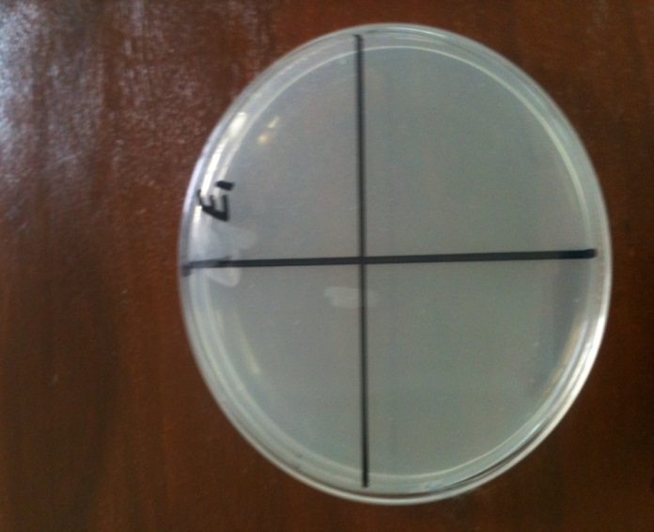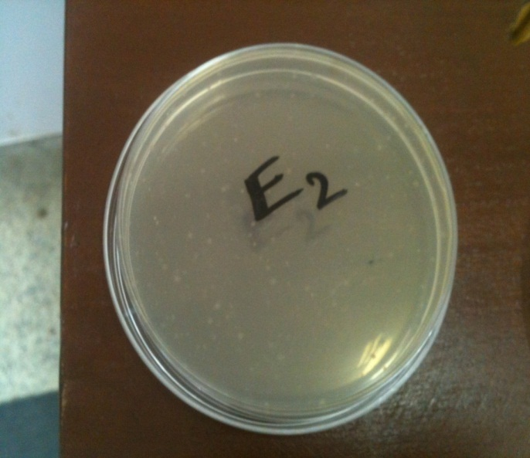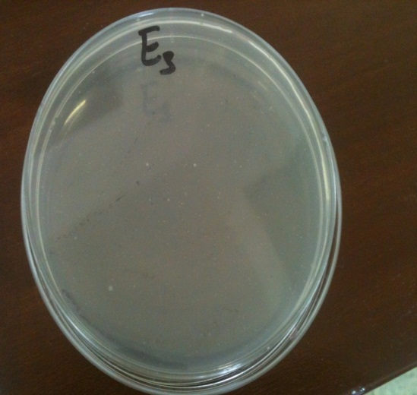

**(E1) (E2) (E3)**

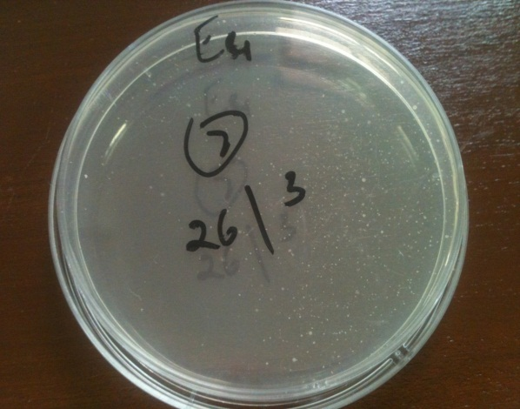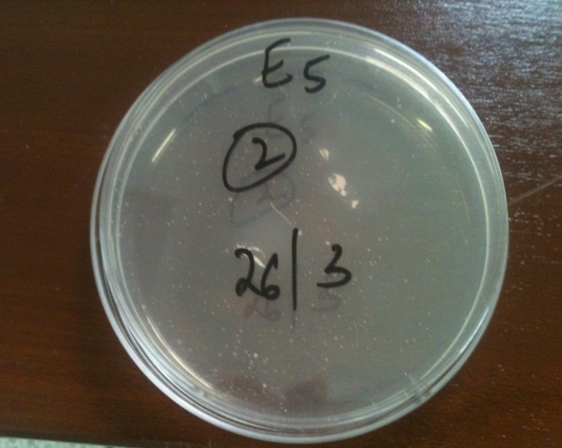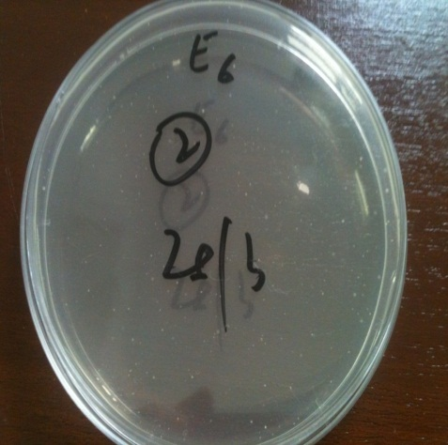

**(E4) (E5) (E6)**

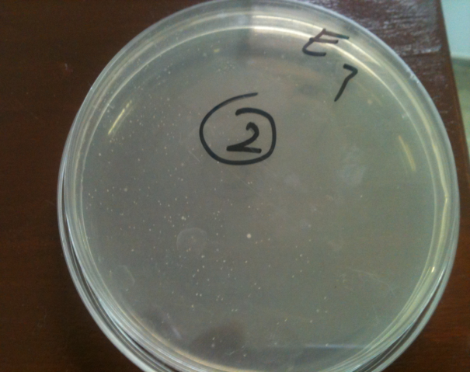

**(E7)**

**Plate 1: Microbial Load of extracts (E1-E7) treated meat sample**

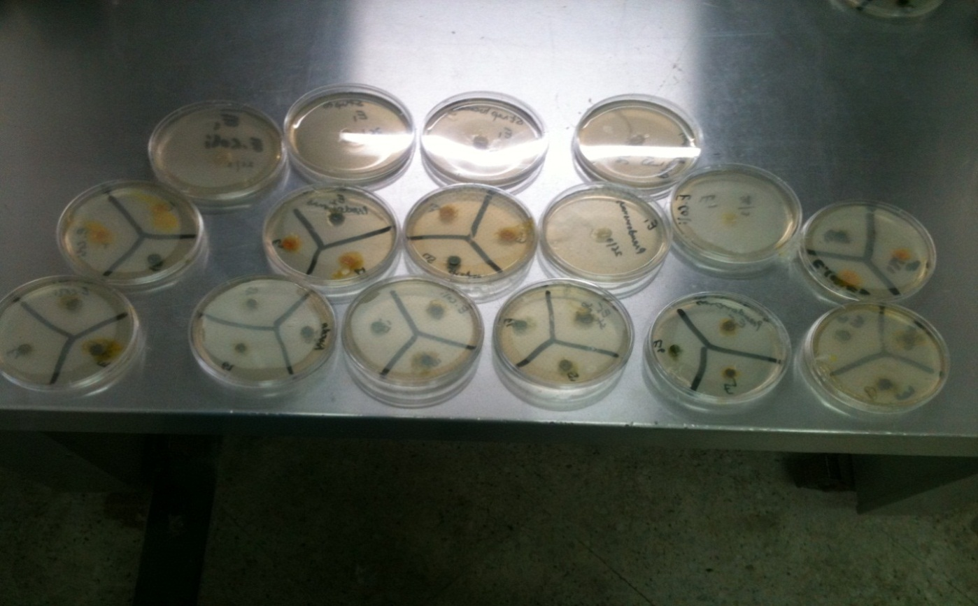

**Plate no.2: Minimum Inhibitory Concentration of Extracts against bacterial strain**

**Figure no.3: Antimicrobial activity of Plant extracts against bacterial strains**

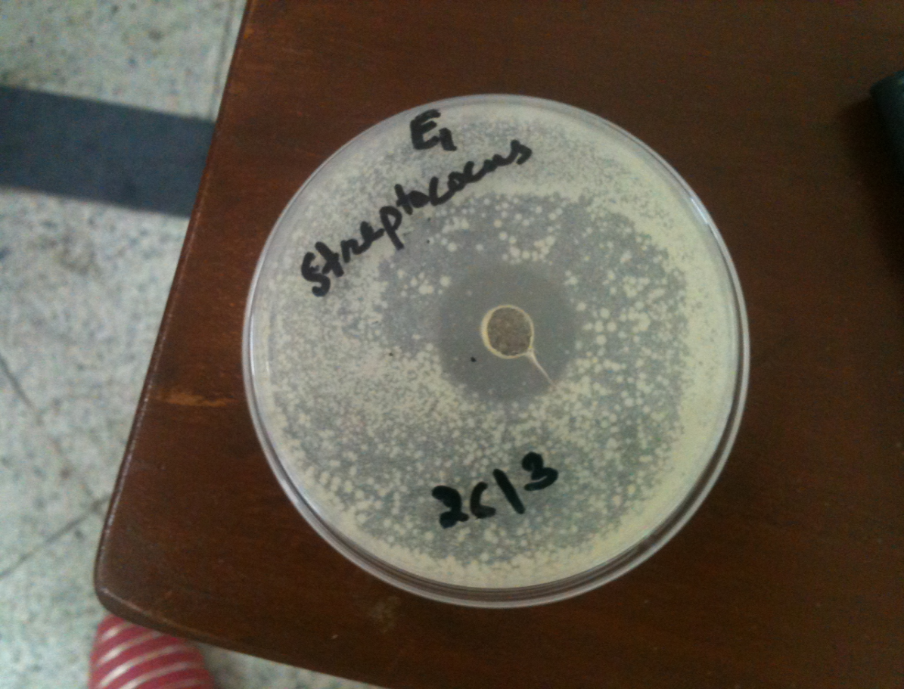

**Plate no. 3: Inhibition Zone of E1 (Garlic) extract against *Streptococcus Sp***

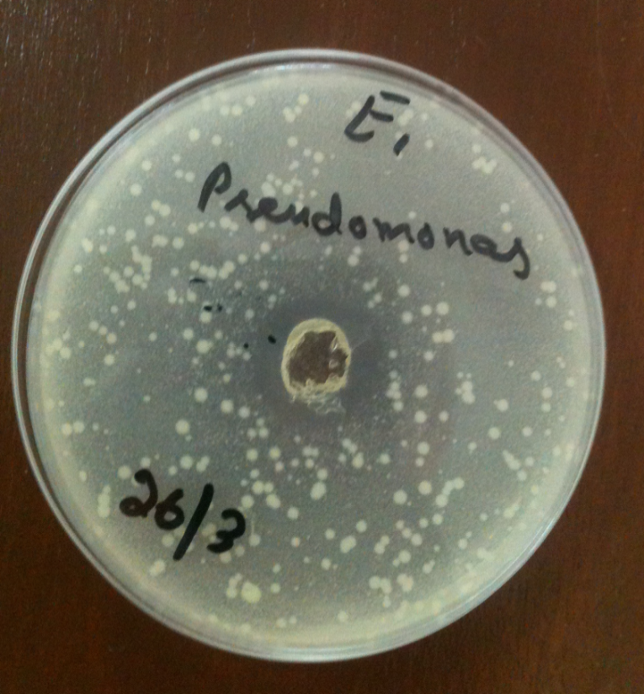

**Plate no. 4: Inhibition zone of E1 (Garlic) Extract against *Pseudomonas Sp***

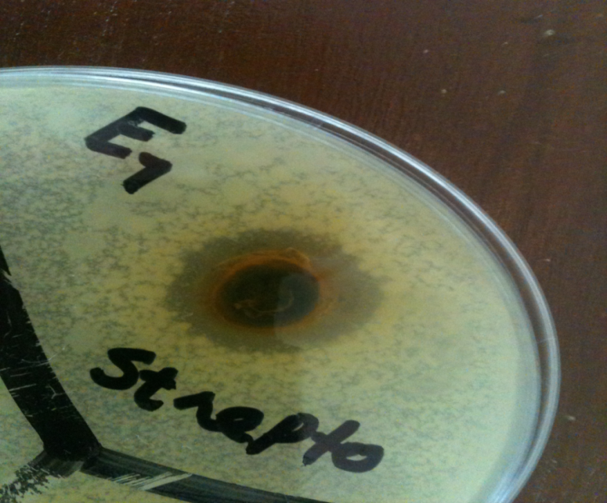

**Plate no. 5: Inhibition zone of E7 (Garlic + Turmeric + Moringa) Extract against *Streptococcus Sp***